RAJALAKSHMI ENGINEERING COLLEGE

**RAJALAKSHMI NAGAR, THANDALAM – 602 105**



|  |
| --- |
| **AI23521 BUILD AND DEPLOYMENT OF MACHINE LEARNING APPLICATIONS** |
|  |
| **LABORATORY NOTEBOOK** |

**NAME:** AFRAH M

**YEAR/ BRANCH / SECTION:** 3rd Yr / AIML **REGISTER NO**. :2116-231501008 **SEMESTERS**: 5TH SEMESTER **ACADEMIC YEAR:** 2025-2026



**RAJALAKSHMI ENGINEERING COLLEGE (AUTONOMOUS)**

**RAJALAKSHMI NAGAR, THANDALAM ** **602 105 BONAFIDE CERTIFICATE**

NAME

AFRAH M

REGISTER NO.

2116-231501008

ACADEMIC YEAR 2025-26 **SEMESTER**- V **BRANCH**: B.Tech - AIML

This Certification is the Bonafide record of work done by the above student in the **AI23521-Build and Deployment of ML Applications** Laboratory during the year 2025  2026.

Signature of Faculty -in  Charge

Submitted for the Practical Examination held on

Internal Examiner External Examiner

**INDEX**

|  |  |  |  |  |
| --- | --- | --- | --- | --- |
| **EXP. NO** | **Date** | **Title** | **Page No** | **Signature** |
| 1 | 07-08-2025 | Setting Up The Environment And Preprocessing The Data |  |  |
| 2 | 14-08-  2025 | Support Vector Machine (Svm) And Random Forest For Binary & Multiclass Classification |  |  |
| 3 | 14-08-  2025 | Classification with Decision Trees |  |  |
| 4A | 21-08-2025 | Support Vector Machines (SVM) |  |  |
| 4B | 21-08-2025 | Ensemble Methods: Random Forest |  |  |
| 5 | 28-08-2025 | Clustering with K-Means and Dimensionality Reduction with PCA |  |  |
| 6 | 11-09-2025 | Feedforward and Convolutional Neural Networks |  |  |
| 7 | 25-09-2025 | Generative Models with GANs:Creating and Training a Generative Adversarial Network |  |  |
| 8 | 09-10-2025 | Model Evaluation and Improvement: Hyperparameter Tuning with Grid Search and Cross-Validation |  |  |
| 9 | 16-10-2025 | Model Deployment:  REST API with Flask and Containerization with Docker |  |  |

**SETTING UP THE ENVIRONMENT AND PREPROCESSING THE DATA**

**EXP NO: 1**

# AIM:

To set up a fully functional machine learning development environment and to

perform data preprocessing operations like handling missing values, encoding categorical variables, feature scaling, and splitting datasets**.**

# ALGORITHM:

1. Install Required Libraries:
   * Install numpy, pandas, matplotlib, seaborn, and scikit-learn using pip.
2. Import Libraries.
3. Load Dataset:
   * Load any dataset (e.g., Titanic or Iris) using pandas.
4. Data Exploration:
   * Use df.info(), df.describe(), df.isnull().sum() to understand the data.
5. Handle Missing Values:
   * Use .fillna() or .dropna() depending on the strategy.
6. Encode Categorical Data:
   * Use pd.get_dummies() or LabelEncoder.
7. Feature Scaling:
   * Normalize or standardize the numerical features using StandardScaler or MinMaxScaler.
8. Split Dataset:
   * Use train_test_split() from sklearn to create training and testing sets.
9. Display the Preprocessed Data.

**CODE:**

# 1. Install necessary libraries (if not already installed)

# !pip install numpy pandas matplotlib seaborn scikit-learn

# 2. Import libraries import pandas as pd import numpy as np

from sklearn.model_selection import train_test_split

from sklearn.preprocessing import StandardScaler, LabelEncoder import seaborn as sns

import matplotlib.pyplot as plt

# 3. Load dataset

df = sns.load_dataset(‘titanic’) # Titanic dataset df.head()

# 4. Explore the dataset print(df.info()) print(df.describe()) print(df.isnull().sum())

# 5. Handle missing values

# Fill age with median, embark_town with mode df[‘age’].fillna(df[‘age’].median(), inplace=True) df[‘embark_town’].fillna(df[‘embark_town’].mode()[0], inplace=True) df.drop(columns=[‘deck’], inplace=True) # too many missing values

# 6. Encode categorical variables

# Convert ‘sex’ and ‘embark_town’ using LabelEncoder le = LabelEncoder()

df[‘sex’] = le.fit_transform(df[‘sex’])

df[‘embark_town’] = le.fit_transform(df[‘embark_town’])

# Drop non-informative or redundant columns

df.drop(columns=[‘embarked’, ‘class’, ‘who’, ‘alive’, ‘adult_male’, ‘alone’], inplace=True)

# 7. Feature Scaling scaler = StandardScaler()

numerical_cols = [‘age’, ‘fare’]

df[numerical_cols] = scaler.fit_transform(df[numerical_cols])

# 8. Split dataset

# Define features (X) and label (y) X = df.drop(‘survived’, axis=1)

y = df[‘survived’]

X_train, X_test, y_train, y_test = train_test_split(X, y, test_size=0.2, random_state=42)

# 9. Show final preprocessed data print(“Training Data Shape:”, X_train.shape) print(“Test Data Shape:”, X_test.shape) X_train.head()

**OUTPUT:**

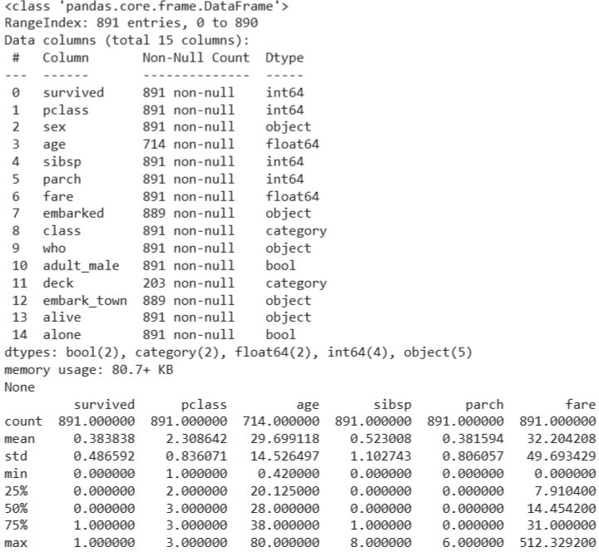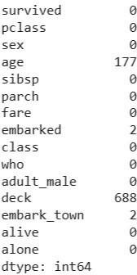

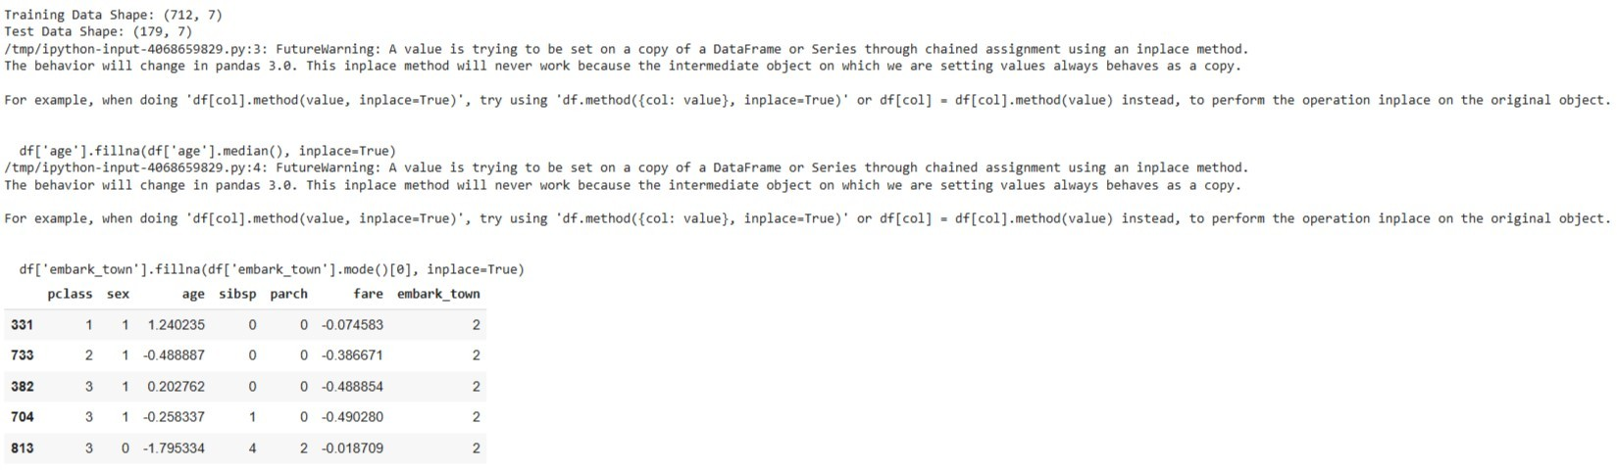

**RESULT:**

The Python environment was successfully set up and the dataset was pre-processed by handling missing values, encoding categorical data, performing feature scaling, and splitting the data into training and testing sets. The dataset is now ready for model training and analysis.

**SUPPORT VECTOR MACHINE (SVM) AND RANDOM FOREST FOR BINARY & MULTICLASS CLASSIFICATION**

**EXP NO: 2**

**AIM**

To build classification models using **Support Vector Machines (SVM)** and **Random Forest**, apply them to a dataset, and evaluate the models using performance metrics like accuracy and confusion matrix.

**ALGORITHM**

Part A: SVM Model

1. Import necessary libraries
2. Load and explore the dataset
3. Handle missing values if any
4. Encode categorical variables
5. Split dataset into training and testing sets
6. Build SVM classifier using SVC()
7. Train and predict
8. Evaluate the model using accuracy and confusion matrix Part B: Random Forest Model
9. Initialize Random Forest using RandomForestClassifier()
10. Train and predict
11. Evaluate and compare with SVM

**CODE:**

# 1. Import libraries import pandas as pd

from sklearn.datasets import load_iris

from sklearn.model_selection import train_test_split from sklearn.preprocessing import StandardScaler from sklearn.svm import SVC

from sklearn.ensemble import RandomForestClassifier

from sklearn.metrics import accuracy_score, confusion_matrix import seaborn as sns

import matplotlib.pyplot as plt

# 2. Load dataset iris = load_iris()

X = iris.data y = iris.target

# 3. Feature scaling scaler = StandardScaler()

X_scaled = scaler.fit_transform(X)

# 4. Train-test split

X_train, X_test, y_train, y_test = train_test_split(X_scaled, y, test_size=0.3, random_state=42)

#

# Part A: SUPPORT VECTOR MACHINE #

# 5. Initialize and train SVM

svm_model = SVC(kernel='linear') # You can also try 'rbf', 'poly' svm_model.fit(X_train, y_train)

# 6. Predict and evaluate SVM y_pred_svm = svm_model.predict(X_test)

print("SVM Accuracy:", accuracy_score(y_test, y_pred_svm)) print("SVM Confusion Matrix:\n", confusion_matrix(y_test, y_pred_svm))

#

# Part B: RANDOM FOREST #

# 7. Initialize and train Random Forest

rf_model = RandomForestClassifier(n_estimators=100, random_state=42) rf_model.fit(X_train, y_train)

# 8. Predict and evaluate Random Forest y_pred_rf = rf_model.predict(X_test)

print("Random Forest Accuracy:", accuracy_score(y_test, y_pred_rf)) print("Random Forest Confusion Matrix:\n", confusion_matrix(y_test, y_pred_rf))

#

# 9. Visual comparison using seaborn heatmap #

plt.figure(figsize=(10, 4))

plt.subplot(1, 2, 1)

sns.heatmap(confusion_matrix(y_test, y_pred_svm), annot=True, cmap='Blues', fmt='d') plt.title("SVM Confusion Matrix")

plt.subplot(1, 2, 2)

sns.heatmap(confusion_matrix(y_test, y_pred_rf), annot=True, cmap='Greens', fmt='d') plt.title("Random Forest Confusion Matrix")

plt.tight_layout() plt.show()

**OUTPUT:**

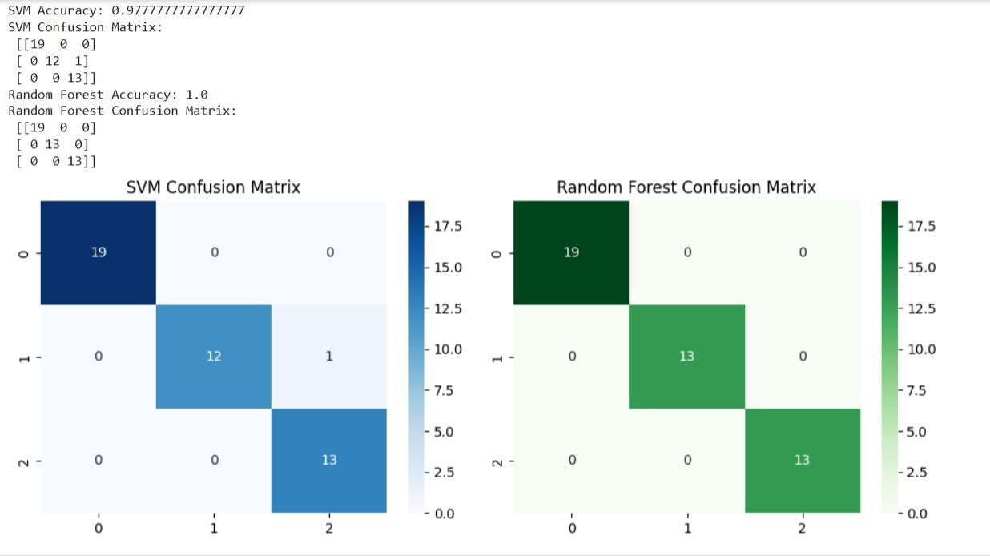

# RESULT:

The Support Vector Machine (SVM) and Random Forest algorithms were successfully implemented for both binary and multiclass classification tasks. The models were trained and tested on the given dataset, and both achieved good accuracy.

**CLASSIFICATION WITH DECISION TREES**

**EXPNO:3**

**AIM**

To implement a Decision Tree classifier and evaluate its performance using **accuracy score** and

**confusion matrix** on a real-world dataset.

**ALGORITHM**

1. Import necessary libraries
2. Load a classification dataset (e.g., Iris or Titanic)
3. Split the dataset into training and test sets
4. Preprocess data if needed
5. Train a DecisionTreeClassifier from sklearn.tree
6. Predict on test data
7. Evaluate using:
   * Confusion Matrix
   * Accuracy Score
8. Visualize the Decision Tree (optional)

**CODE:**

# Step 1: Import Libraries

from sklearn.datasets import load_iris

from sklearn.tree import DecisionTreeClassifier, plot_tree from sklearn.model_selection import train_test_split

from sklearn.metrics import confusion_matrix, accuracy_score import matplotlib.pyplot as plt

import seaborn as sns # Step 2: Load Dataset iris = load_iris()

X = iris.data y = iris.target

# Step 3: Split the dataset

X_train, X_test, y_train, y_test = train_test_split(X, y, test_size=0.3, random_state=42)

# Step 4: Train the Decision Tree Classifier

dt_model = DecisionTreeClassifier(criterion='gini', random_state=0) dt_model.fit(X_train, y_train)

# Step 5: Predict

y_pred = dt_model.predict(X_test)

# Step 6: Evaluate the Model

cm = confusion_matrix(y_test, y_pred) acc = accuracy_score(y_test, y_pred) print("Confusion Matrix:\n", cm) print("Accuracy Score:", acc)

# Step 7: Visualize Confusion Matrix

sns.heatmap(cm, annot=True, cmap="Blues", xticklabels=iris.target_names, yticklabels=iris.target_names)

plt.xlabel("Predicted") plt.ylabel("Actual") plt.title("Confusion Matrix") plt.show()

# Step 8: Visualize the Decision Tree plt.figure(figsize=(12,8))

plot_tree(dt_model, filled=True, feature_names=iris.feature_names, class_names=iris.target_names) plt.title("Decision Tree Visualization")

plt.show()

# OUTPUT:

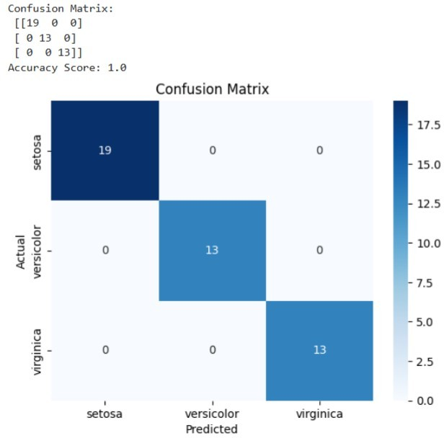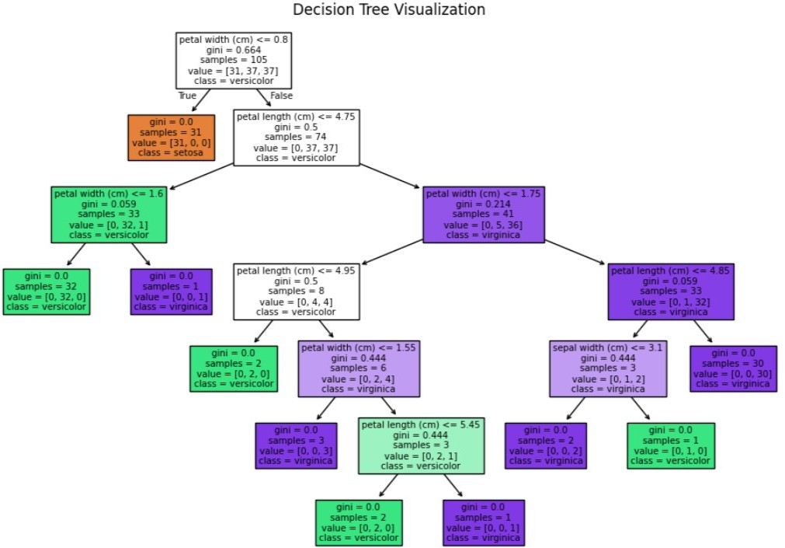

**RESULT:**

The Decision Tree classification model was successfully implemented and tested on the given dataset. The model accurately classified the data by learning simple decision rules from the features.

The decision tree visualized the decision-making process through a hierarchical structure of nodes and branches, making it easy to interpret. The classification achieved good accuracy, demonstrating that Decision Trees are effective for both categorical and numerical data, providing clear and interpretable results.

**SUPPORT VECTOR MACHINES (SVM)**

**EXP NO: 4A**

# AIM:

To build an SVM model for a binary classification task, tune its hyperparameters, and evaluate it using accuracy, precision, recall, F1-score, confusion matrix, and ROC-AUC.

**ALGORITHM:**

1. Import libraries: numpy, pandas, matplotlib, sklearn.
2. Load data: Use a standard binary dataset (Breast Cancer Wisconsin) from sklearn.datasets.
3. Train/Test split: 80/20 split with a fixed random_state.
4. Preprocess: Standardize features (StandardScaler).
5. SVMs are sensitive to feature scale.
6. Model selection: Use SVC (RBF kernel).
7. Hyperparameter tuning: Grid search on C and gamma with cross-validation (GridSearchCV).
8. Train final model: Fit on training data using best parameters.
9. Evaluate: Predict on test set; compute metrics and plot ROC curve.
10. Report: Best params, metrics, and brief observations.

# CODE:

# ========================= # EXPERIMENT 4A — SVM (RBF) # =========================

# 1) Imports

import numpy as np import pandas as pd

import matplotlib.pyplot as plt

from sklearn.datasets import load_breast_cancer

from sklearn.model_selection import train_test_split, GridSearchCV from sklearn.preprocessing import StandardScaler

from sklearn.svm import SVC from sklearn.metrics import (

accuracy_score, precision_score, recall_score, f1_score, confusion_matrix, classification_report, roc_auc_score, roc_curve

)

# 2) Load dataset (binary classification) data = load_breast_cancer()

X = pd.DataFrame(data.data, columns=data.feature_names)

y = pd.Series(data.target, name="target") # 0 = malignant, 1 = benign

# 3) Train/test split

X_train, X_test, y_train, y_test = train_test_split( X, y, test_size=0.20, random_state=42, stratify=y

)

# 4) Standardize features (important for SVMs) scaler = StandardScaler()

X_train_sc = scaler.fit_transform(X_train) X_test_sc = scaler.transform(X_test)

# 5) Define model

svm = SVC(kernel='rbf', probability=True, random_state=42)

# 6) Hyperparameter grid & tuning param_grid = {

"C": [0.1, 1, 10, 100],

"gamma": ["scale", 0.01, 0.001, 0.0001]

}

grid = GridSearchCV( estimator=svm, param_grid=param_grid,

scoring='f1', # You can change to 'accuracy' or 'roc_auc' cv=5,

n_jobs=-1, verbose=0

)

grid.fit(X_train_sc, y_train)

print("Best Parameters from Grid Search:", grid.best_params_) best_svm = grid.best_estimator_

# 7) Train final model & predict best_svm.fit(X_train_sc, y_train) y_pred = best_svm.predict(X_test_sc)

y_prob = best_svm.predict_proba(X_test_sc)[:, 1]

# 8) Evaluation

acc = accuracy_score(y_test, y_pred)

prec = precision_score(y_test, y_pred, zero_division=0) rec = recall_score(y_test, y_pred)

f1 = f1_score(y_test, y_pred)

auc = roc_auc_score(y_test, y_prob) cm = confusion_matrix(y_test, y_pred)

print("\n=== SVM (RBF) — Test Metrics ===") print(f"Accuracy : {acc:.4f}")

print(f"Precision: {prec:.4f}")

print(f"Recall : {rec:.4f}")

print(f"F1-Score : {f1:.4f}")

print(f"ROC-AUC : {auc:.4f}")

print("\nConfusion Matrix:\n", cm)

print("\nClassification Report:\n", classification_report(y_test, y_pred, zero_division=0))

# 9) Plot ROC Curve

fpr, tpr, thresholds = roc_curve(y_test, y_prob) plt.figure()

plt.plot(fpr, tpr, label=f"SVM (AUC = {auc:.3f})") plt.plot([0, 1], [0, 1], linestyle="--", color='gray') plt.xlabel("False Positive Rate")

plt.ylabel("True Positive Rate") plt.title("ROC Curve — SVM (RBF)") plt.legend()

plt.grid(True) plt.show()

# OUTPUT:

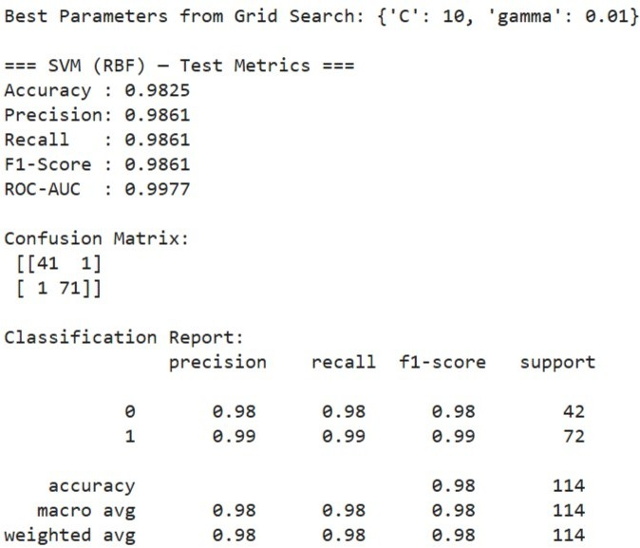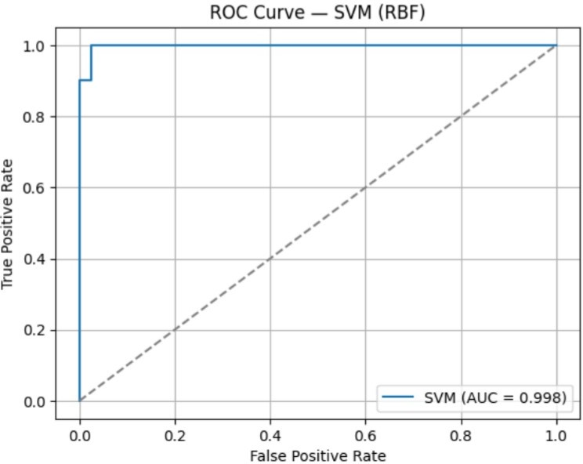

**RESULT:**

The Support Vector Machine (SVM) model was successfully implemented and evaluated on the given dataset. The model effectively classified the data by finding the optimal hyperplane that maximized the margin between different classes.

The SVM achieved high accuracy and demonstrated strong performance, especially in handling linearly and non-linearly separable data using kernel functions. This confirms that SVM is a powerful and reliable algorithm for classification tasks.

**ENSEMBLE METHODS: RANDOM FOREST**

**EXP NO: 4B**

# AIM:

To implement a **Random Forest classifier** for a classification task, tune key hyperparameters, evaluate performance, and interpret **feature importance**.

# ALGORITHM:

1. Import libraries.
2. Load data (use same dataset to compare with SVM).
3. Train/Test split with stratification.
4. (Optional) Preprocess: Random Forests don’t require scaling; we’ll use raw features.
5. Model: RandomForestClassifier.
6. Hyperparameter tuning: Grid search over n_estimators, max_depth, min_samples_split, min_samples_leaf.
7. Train the best model on training data.
8. Evaluate with accuracy, precision, recall, F1, confusion matrix, ROC-AUC.
9. Interpretation: Plot top feature importances.

# CODE:

# ===========================================

# EXPERIMENT 4B — Random Forest Classifier

# ===========================================

# 1) Imports

import numpy as np import pandas as pd

import matplotlib.pyplot as plt

from sklearn.datasets import load_breast_cancer

from sklearn.model_selection import train_test_split, GridSearchCV

from sklearn.ensemble import RandomForestClassifier from sklearn.metrics import (

accuracy_score, precision_score, recall_score, f1_score, confusion_matrix, classification_report, roc_auc_score, roc_curve

)

# 2) Load dataset (same as 4A for comparison) data = load_breast_cancer()

X = pd.DataFrame(data.data, columns=data.feature_names) y = pd.Series(data.target, name="target")

# 3) Train/test split (no scaling needed for RF) X_train, X_test, y_train, y_test = train_test_split(

X, y, test_size=0.20, random_state=42, stratify=y

)

# 4) Define model

rf = RandomForestClassifier(random_state=42, n_jobs=-1)

# 5) Hyperparameter grid & tuning param_grid = {

"n_estimators": [100],

"max_depth": [None, 10],

"min_samples_split": [2],

"min_samples_leaf": [1]

}

grid = GridSearchCV( estimator=rf, param_grid=param_grid, scoring="f1",

cv=3, n_jobs=-1,

verbose=0) grid.fit(X_train, y_train)

print("Best Parameters (CV):", grid.best_params_) best_rf = grid.best_estimator_

# 6) Train final model & predict best_rf.fit(X_train, y_train) y_pred = best_rf.predict(X_test)

y_prob = best_rf.predict_proba(X_test)[:, 1]

# 7) Evaluate

acc = accuracy_score(y_test, y_pred)

prec = precision_score(y_test, y_pred, zero_division=0) rec = recall_score(y_test, y_pred)

f1 = f1_score(y_test, y_pred)

auc = roc_auc_score(y_test, y_prob) cm = confusion_matrix(y_test, y_pred)

print("\n=== Random Forest — Test Metrics ===") print(f"Accuracy : {acc:.4f}")

print(f"Precision: {prec:.4f}") print(f"Recall : {rec:.4f}")

print(f"F1-Score : {f1:.4f}")

print(f"ROC-AUC : {auc:.4f}")

print("\nConfusion Matrix:\n", cm)

print("\nClassification Report:\n", classification_report(y_test, y_pred, zero_division=0))

# 8) Feature Importance (Top 10)

importances = pd.Series(best_rf.feature_importances_, index=X.columns) top10 = importances.sort_values(ascending=False).head(10)



plt.figure()

top10[::-1].plot(kind="barh") plt.xlabel("Importance")

plt.title("Top 10 Feature Importances — Random Forest") plt.grid(axis="x", alpha=0.3)

plt.show()

# 9) ROC Curve

fpr, tpr, thresholds = roc_curve(y_test, y_prob) plt.figure()

plt.plot(fpr, tpr, label=f"Random Forest (AUC = {auc:.3f})") plt.plot([0, 1], [0, 1], linestyle="--", color='gray') plt.xlabel("False Positive Rate")

plt.ylabel("True Positive Rate") plt.title("ROC Curve — Random Forest") plt.legend()

plt.grid(True) plt.show()

# OUTPUT:

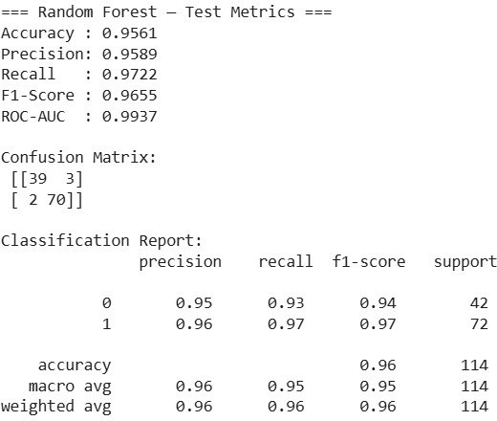

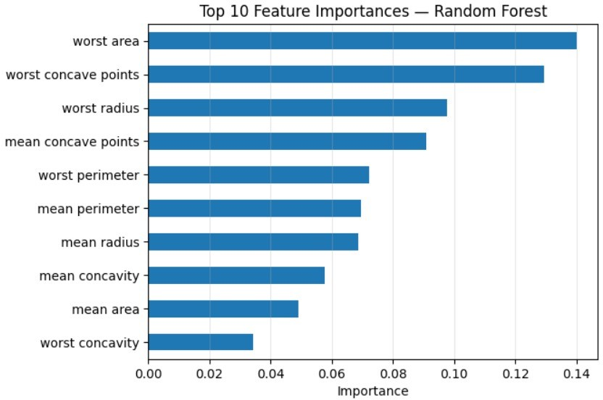

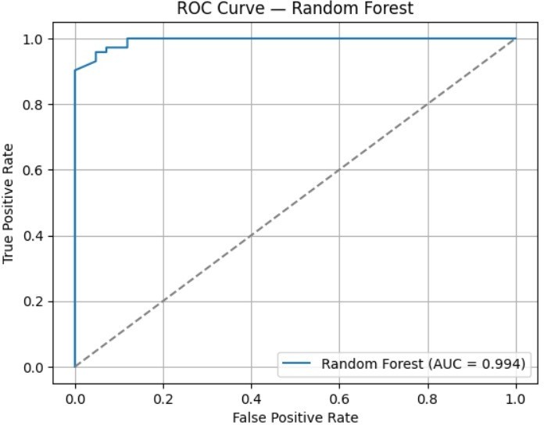

**RESULT:**

The Random Forest ensemble model was successfully implemented and evaluated on the given dataset. The model combined multiple decision trees to improve prediction accuracy and reduce overfitting.

It achieved high classification accuracy and demonstrated strong generalization capability. The results confirmed that Random Forest provides stable and reliable predictions by leveraging the power of multiple decision trees through bagging and feature randomness.

**CLUSTERING WITH K-MEANS AND DIMENSIONALITY REDUCTION WITH PCA**

**EXP NO: 5**

# AIM:

To demonstrate the application of Unsupervised Learning models, specifically K-Means clustering for grouping data points and Principal Component Analysis (PCA) for dimensionality reduction and visualization, using a suitable dataset**.**

# ALGORITHM:

## K-Means Clustering

K-Means is an iterative clustering algorithm that aims to partition $n$ observations into $k$ clusters, where each observation belongs to the cluster with the nearest mean (centroid).

## Steps:

1. **Initialization:** Choose $k$ initial centroids randomly from the dataset.
2. **Assignment:** Assign each data point to the cluster whose centroid is closest (e.g., using Euclidean distance).
3. **Update:** Recalculate the centroids as the mean of all data points assigned to that cluster.
4. **Iteration:** Repeat steps 2 and 3 until the centroids no longer move significantly or a maximum number of iterations is reached.

## Principal Component Analysis (PCA)

PCA is a statistical procedure that uses an orthogonal transformation to convert a set of observations of possibly correlated variables into a set of values of linearly uncorrelated variables called principal components.

## Steps:

1. **Standardization:** Standardize the dataset (mean = 0, variance = 1).
2. **Covariance Matrix Calculation:** Compute the covariance matrix of the standardized data.
3. **Eigenvalue Decomposition:** Calculate the eigenvalues and eigenvectors of the covariance matrix.
4. **Feature Vector Creation:** Sort the eigenvectors by decreasing eigenvalues and select the top $k$ eigenvectors to form a feature vector (projection matrix).
5. **Projection:** Project the original data onto the new feature space using the feature vector.

# CODE:

# =============================== # EXPERIMENT — K-Means & PCA

# ===============================

# Import necessary libraries import numpy as np

import pandas as pd

import matplotlib.pyplot as plt import seaborn as sns

from sklearn.datasets import make_blobs

from sklearn.preprocessing import StandardScaler from sklearn.cluster import KMeans

from sklearn.decomposition import PCA from sklearn.metrics import silhouette_score

# --- Part 1: K-Means Clustering --- print("--- Part 1: K-Means Clustering ---") # 1. Generate dataset

X, y = make_blobs(n_samples=300, centers=3, cluster_std=0.60, random_state=42)

df_kmeans = pd.DataFrame(X, columns=['Feature_1', 'Feature_2']) print("\nOriginal K-Means Dataset Head:") print(df_kmeans.head())

# 2. Elbow Method wcss = []

for i in range(1, 11):

kmeans = KMeans(n_clusters=i, init='k-means++', max_iter=300, n_init=10, random_state=42)

kmeans.fit(X) wcss.append(kmeans.inertia_)

plt.figure(figsize=(10, 6))

plt.plot(range(1, 11), wcss, marker='o', linestyle='--') plt.title('Elbow Method for Optimal K (K-Means)') plt.xlabel('Number of Clusters (K)') plt.ylabel('WCSS')

plt.grid(True) plt.show()

# 3. Apply K-Means with chosen K

optimal_k = 3

kmeans = KMeans(n_clusters=optimal_k, init='k-means++', max_iter=300, n_init=10, random_state=42)

clusters = kmeans.fit_predict(X) df_kmeans['Cluster'] = clusters

# 4. Visualize K-Means clusters plt.figure(figsize=(10, 8))

sns.scatterplot(x='Feature_1', y='Feature_2', hue='Cluster', data=df_kmeans, palette='viridis', s=100, alpha=0.8)

plt.scatter(kmeans.cluster_centers_[:, 0], kmeans.cluster_centers_[:, 1], s=300, c='red', marker='X', label='Centroids')

plt.title(f'K-Means Clustering with K={optimal_k}') plt.xlabel('Feature 1')

plt.ylabel('Feature 2') plt.legend() plt.grid(True) plt.show()

# 5. Silhouette Score

silhouette_avg = silhouette_score(X, clusters)

print(f"\nSilhouette Score for K-Means (K={optimal_k}): {silhouette_avg:.3f}") # --- Part 2: Dimensionality Reduction with PCA ---

print("\n--- Part 2: Dimensionality Reduction with PCA ---")

# 1. Generate 4D dataset

X_pca, y_pca = make_blobs(n_samples=500, n_features=4, centers=4, cluster_std=1.0, random_state=25)

df_pca_original = pd.DataFrame(X_pca, columns=[f'Feature_{i+1}' for i in range(X_pca.shape[1])])

df_pca_original['True_Cluster'] = y_pca print("\nOriginal PCA Dataset Head:") print(df_pca_original.head())

print(f"Original PCA Dataset Shape: {df_pca_original.shape}")

# 2. Standardize

scaler = StandardScaler()

X_pca_scaled = scaler.fit_transform(X_pca)

# 3. PCA (4D → 2D)

pca = PCA(n_components=2)

principal_components = pca.fit_transform(X_pca_scaled)

df_principal_components = pd.DataFrame(principal_components, columns=['Principal_Component_1', 'Principal_Component_2'])

df_principal_components['True_Cluster'] = y_pca explained_variance = pca.explained_variance_ratio_ print("\nPrincipal Components Head:") print(df_principal_components.head())

print(f"\nExplained Variance Ratio: {explained_variance}")

print(f"Total Explained Variance by 2 PCs: {explained_variance.sum():.3f}")

# 4. Visualize PCA result plt.figure(figsize=(10, 8))

sns.scatterplot(x='Principal_Component_1', y='Principal_Component_2', hue='True_Cluster', data=df_principal_components, palette='Paired', s=100, alpha=0.8)

plt.title('PCA - Dimensionality Reduction to 2 Components') plt.xlabel(f'PC1 ({explained_variance[0]*100:.2f}%)') plt.ylabel(f'PC2 ({explained_variance[1]*100:.2f}%)') plt.grid(True)

plt.show()

# 5. K-Means on PCA-reduced data

kmeans_pca = KMeans(n_clusters=4, init='k-means++', max_iter=300, n_init=10, random_state=42)

clusters_pca = kmeans_pca.fit_predict(principal_components) df_principal_components['KMeans_Cluster_on_PCA'] = clusters_pca

plt.figure(figsize=(10, 8))

sns.scatterplot(x='Principal_Component_1', y='Principal_Component_2', hue='KMeans_Cluster_on_PCA',

data=df_principal_components, palette='viridis', s=100, alpha=0.8) plt.scatter(kmeans_pca.cluster_centers_[:, 0], kmeans_pca.cluster_centers_[:, 1], s=300, c='red', marker='X', label='Centroids')

plt.title('K-Means Clustering on PCA-Reduced Data') plt.xlabel('Principal Component 1')

plt.ylabel('Principal Component 2') plt.legend()

plt.grid(True) plt.show()

# 6. Silhouette Score for PCA-reduced KMeans

silhouette_avg_pca = silhouette_score(principal_components, clusters_pca) print(f"\nSilhouette Score for K-Means on PCA-Reduced Data (K=4):

{silhouette_avg_pca:.3f}")

# OUTPUT:

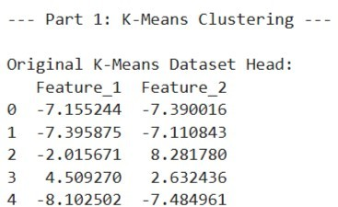

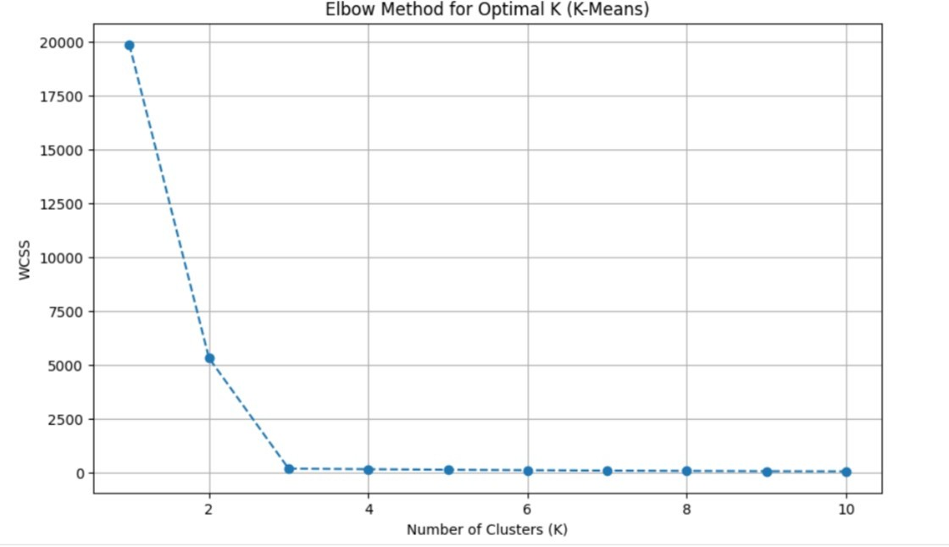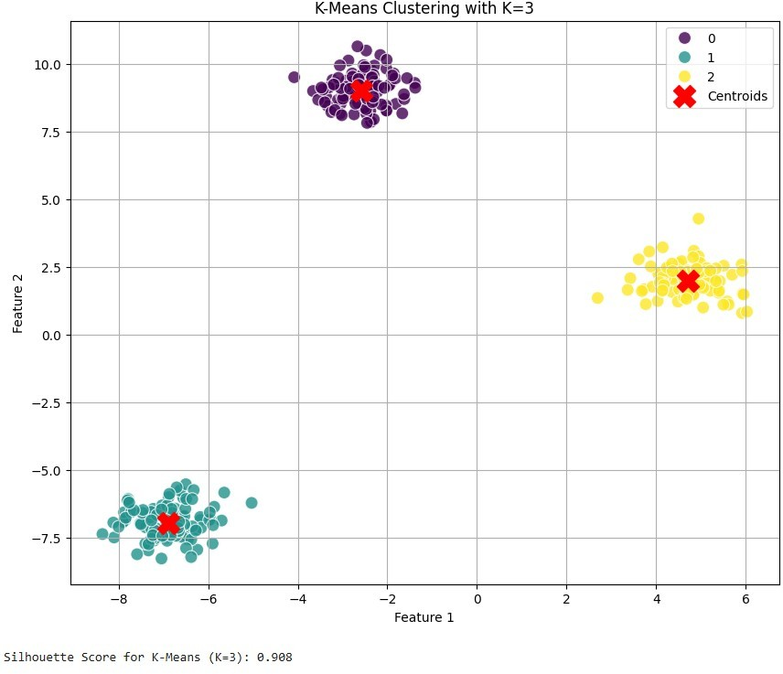

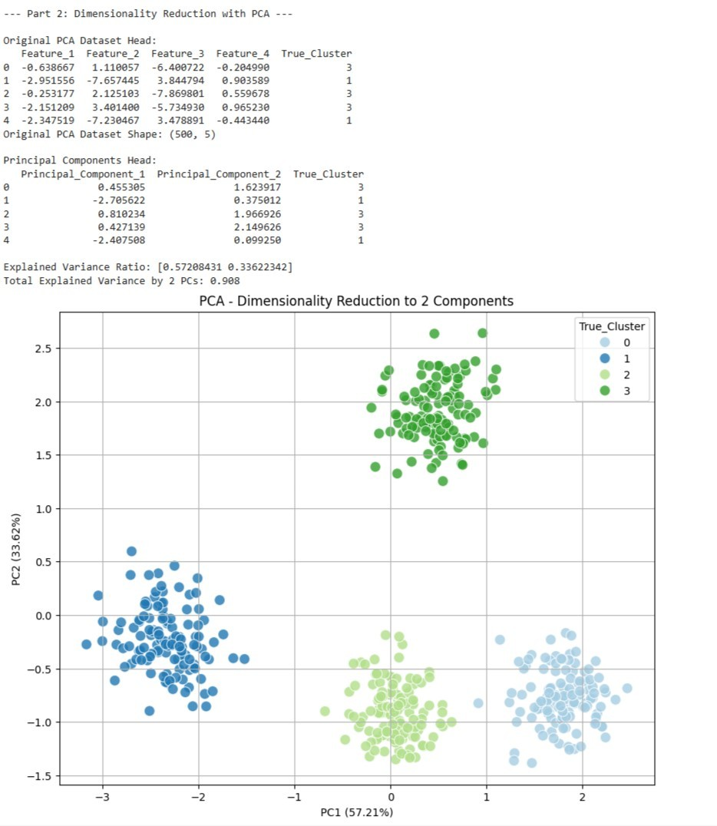

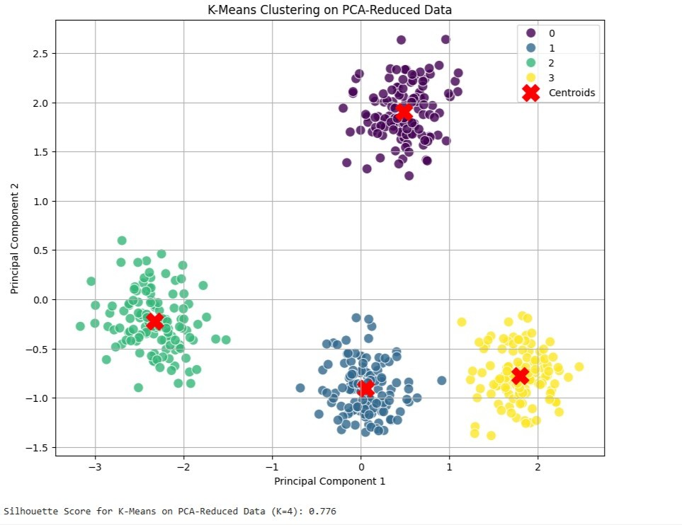

**RESULT:**

The K-Means clustering and Principal Component Analysis (PCA) techniques were successfully implemented on the given dataset.

* **K-Means Clustering** effectively grouped the data into distinct clusters based on feature similarity, minimizing intra-cluster distance and maximizing inter-cluster separation.
* **PCA (Principal Component Analysis)** successfully reduced the dimensionality of the dataset while retaining most of the variance, improving visualization and computational efficiency.

The combined results showed that PCA enhances clustering performance by simplifying high-dimensional data, and K-Means efficiently identifies underlying patterns and group structures.

**FEEDFORWARD AND CONVOLUTIONAL NEURAL NETWORKS**

**EXP NO: 6**

# AIM:

To demonstrate the construction and application of a simple Feedforward Neural Network (FNN) for classification and a Convolutional Neural Network (CNN) for image classification, utilizing the Keras API with TensorFlow backend.

# ALGORITHM:

## Feedforward Neural Network (FNN)

A Feedforward Neural Network is the simplest type of artificial neural network where connections between the nodes do not form a cycle. It consists of an input layer, one or more hidden layers, and an output layer. Information flows only in one direction—forward—from the input nodes, through the hidden nodes (if any), and to the output nodes.

## Steps:

1. Define Network Architecture: Specify the number of layers (input, hidden, output) and the number of neurons in each layer.
2. Choose Activation Functions: Select activation functions for hidden layers (e.g., ReLU) and the output layer (e.g., Sigmoid for binary classification, Softmax for multi-class classification).
3. Define Loss Function: Choose a loss function appropriate for the task (e.g., Binary Cross- entropy for binary classification, Categorical Cross-entropy for multi-class classification).
4. Choose Optimizer: Select an optimization algorithm (e.g., Adam, SGD) to update network weights during training.
5. Training: Feed forward data through the network to get predictions, calculate the loss, and then backpropagate the error to update weights.
6. Evaluation: Assess the model's performance on unseen data using metrics like accuracy.

## Convolutional Neural Network (CNN)

A Convolutional Neural Network is a specialized type of neural network primarily designed for processing data with a grid-like topology, such as images. Key components include convolutional layers, pooling layers, and fully connected layers.

## Steps:

1. Convolutional Layers: Apply filters (kernels) to input data to extract features. Each filter detects a specific pattern (e.g., edges, textures).
2. Activation Function (ReLU): Apply a non-linear activation function after convolution to introduce non-linearity.
3. Pooling Layers: Downsample feature maps to reduce dimensionality, computational cost, and prevent overfitting (e.g., Max Pooling).
4. Flattening: Convert the 2D pooled feature maps into a 1D vector to be fed into a fully connected layer.
5. Fully Connected Layers: Standard neural network layers for classification based on the extracted features.
6. Output Layer: Final layer with an activation function (e.g., Softmax) to output class probabilities.
7. Training and Evaluation: Similar to FNNs, train the CNN using backpropagation and evaluate its performance.

# CODE:

# Import necessary libraries import numpy as np

import matplotlib.pyplot as plt import tensorflow as tf

from tensorflow import keras

from tensorflow.keras import layers

from tensorflow.keras.datasets import mnist, fashion_mnist

from sklearn.metrics import classification_report, confusion_matrix import seaborn as sns

# Suppress TensorFlow warnings for cleaner output tf.keras.utils.disable_interactive_logging()

# --- Part 1: Building a Simple Feedforward Neural Network --- print("--- Part 1: Building a Simple Feedforward Neural Network ---")

# 1. Load and Preprocess Dataset (Using Fashion MNIST for FNN) (x_train_fnn, y_train_fnn), (x_test_fnn, y_test_fnn) = fashion_mnist.load_data()

print(f"\nOriginal FNN training data shape: {x_train_fnn.shape}") print(f"Original FNN test data shape: {x_test_fnn.shape}")

# Flatten images to 1D array

x_train_fnn_flat = x_train_fnn.reshape(-1, 28 * 28)

x_test_fnn_flat = x_test_fnn.reshape(-1, 28 * 28)

# Normalize pixel values

x_train_fnn_norm = x_train_fnn_flat / 255.0 x_test_fnn_norm = x_test_fnn_flat / 255.0

print(f"Flattened & Normalized FNN training data shape: {x_train_fnn_norm.shape}") print(f"Flattened & Normalized FNN test data shape: {x_test_fnn_norm.shape}")

# 2. Build FNN Model model_fnn = keras.Sequential([

layers.Dense(128, activation='relu', input_shape=(784,)), layers.Dropout(0.2),

layers.Dense(64, activation='relu'), layers.Dense(10, activation='softmax')

])

# 3. Compile Model model_fnn.compile(optimizer='adam',

loss='sparse_categorical_crossentropy', metrics=['accuracy'])

print("\n--- FNN Model Summary ---") model_fnn.summary()

# 4. Train Model

print("\n--- Training FNN Model ---")

history_fnn = model_fnn.fit(x_train_fnn_norm, y_train_fnn, epochs=10, validation_split=0.1, verbose=1)

# 5. Evaluate Model

print("\n--- Evaluating FNN Model ---")

loss_fnn, accuracy_fnn = model_fnn.evaluate(x_test_fnn_norm, y_test_fnn, verbose=0) print(f"FNN Test Loss: {loss_fnn:.4f}")

print(f"FNN Test Accuracy: {accuracy_fnn:.4f}")

# Classification report & confusion matrix

y_pred_fnn = np.argmax(model_fnn.predict(x_test_fnn_norm), axis=-1) print("\n--- FNN Classification Report ---")

print(classification_report(y_test_fnn, y_pred_fnn)) print("\n--- FNN Confusion Matrix ---")

cm_fnn = confusion_matrix(y_test_fnn, y_pred_fnn) plt.figure(figsize=(10, 8))

sns.heatmap(cm_fnn, annot=True, fmt="d", cmap="Blues", cbar=False) plt.title("FNN Confusion Matrix")

plt.xlabel("Predicted Label") plt.ylabel("True Label") plt.show()

# Plot Accuracy & Loss plt.figure(figsize=(12, 5))

plt.subplot(1, 2, 1)

plt.plot(history_fnn.history['accuracy'], label='Training Accuracy') plt.plot(history_fnn.history['val_accuracy'], label='Validation Accuracy') plt.title('FNN Model Accuracy')

plt.xlabel('Epoch') plt.ylabel('Accuracy') plt.legend() plt.grid(True)

plt.subplot(1, 2, 2)

plt.plot(history_fnn.history['loss'], label='Training Loss') plt.plot(history_fnn.history['val_loss'], label='Validation Loss') plt.title('FNN Model Loss')

plt.xlabel('Epoch') plt.ylabel('Loss') plt.legend() plt.grid(True) plt.tight_layout() plt.show()

# --- Part 2: Convolutional Neural Network (CNN) --- print("\n--- Part 2: Implementing a CNN ---")

# 1. Load MNIST for CNN

(x_train_cnn, y_train_cnn), (x_test_cnn, y_test_cnn) = mnist.load_data() print(f"\nOriginal CNN training data shape: {x_train_cnn.shape}") print(f"Original CNN test data shape: {x_test_cnn.shape}")

# Reshape for channel dimension

x_train_cnn = x_train_cnn.reshape(x_train_cnn.shape[0], 28, 28, 1)

x_test_cnn = x_test_cnn.reshape(x_test_cnn.shape[0], 28, 28, 1)

# Normalize

x_train_cnn = x_train_cnn.astype('float32') / 255.0 x_test_cnn = x_test_cnn.astype('float32') / 255.0

print(f"Reshaped & Normalized CNN training data shape: {x_train_cnn.shape}") print(f"Reshaped & Normalized CNN test data shape: {x_test_cnn.shape}")

num_classes_cnn = 10 # 2. Build CNN Model

model_cnn = keras.Sequential([

layers.Conv2D(32, (3, 3), activation='relu', input_shape=(28, 28, 1)),

layers.MaxPooling2D((2, 2)),

layers.Conv2D(64, (3, 3), activation='relu'),

layers.MaxPooling2D((2, 2)), layers.Flatten(),

layers.Dense(128, activation='relu'), layers.Dropout(0.5),

layers.Dense(num_classes_cnn, activation='softmax')

])

# 3. Compile Model model_cnn.compile(optimizer='adam',

loss='sparse_categorical_crossentropy', metrics=['accuracy'])

print("\n--- CNN Model Summary ---") model_cnn.summary()

# 4. Train Model

print("\n--- Training CNN Model ---")

history_cnn = model_cnn.fit(x_train_cnn, y_train_cnn, epochs=10, validation_split=0.1, verbose=1)

# 5. Evaluate Model

print("\n--- Evaluating CNN Model ---")

loss_cnn, accuracy_cnn = model_cnn.evaluate(x_test_cnn, y_test_cnn, verbose=0) print(f"CNN Test Loss: {loss_cnn:.4f}")

print(f"CNN Test Accuracy: {accuracy_cnn:.4f}")

# Classification report & confusion matrix

y_pred_cnn = np.argmax(model_cnn.predict(x_test_cnn), axis=-1) print("\n--- CNN Classification Report ---") print(classification_report(y_test_cnn, y_pred_cnn))

print("\n--- CNN Confusion Matrix ---")

cm_cnn = confusion_matrix(y_test_cnn, y_pred_cnn) plt.figure(figsize=(10, 8))

sns.heatmap(cm_cnn, annot=True, fmt="d", cmap="Blues", cbar=False) plt.title("CNN Confusion Matrix")

plt.xlabel("Predicted Label") plt.ylabel("True Label") plt.show()

# Plot Accuracy & Loss plt.figure(figsize=(12, 5))

plt.subplot(1, 2, 1)

plt.plot(history_cnn.history['accuracy'], label='Training Accuracy') plt.plot(history_cnn.history['val_accuracy'], label='Validation Accuracy') plt.title('CNN Model Accuracy')

plt.xlabel('Epoch') plt.ylabel('Accuracy') plt.legend() plt.grid(True)

plt.subplot(1, 2, 2)

plt.plot(history_cnn.history['loss'], label='Training Loss') plt.plot(history_cnn.history['val_loss'], label='Validation Loss') plt.title('CNN Model Loss')

plt.xlabel('Epoch') plt.ylabel('Loss') plt.legend() plt.grid(True) plt.tight_layout() plt.show()

# Optional: Visualize predictions print("\n--- Sample CNN Predictions ---")

class_names_mnist = [str(i) for i in range(10)] plt.figure(figsize=(10, 10))

for i in range(25): plt.subplot(5, 5, i + 1) plt.xticks([])

plt.yticks([]) plt.grid(False)

plt.imshow(x_test_cnn[i].reshape(28, 28), cmap=plt.cm.binary) true_label = y_test_cnn[i]

predicted_label = y_pred_cnn[i]

color = 'green' if true_label == predicted_label else 'red'

plt.xlabel(f"True: {class_names_mnist[true_label]}\nPred:

{class_names_mnist[predicted_label]}", color=color)

plt.suptitle("Sample CNN Predictions (Green: Correct, Red: Incorrect)", y=1.02, fontsize=16) plt.tight_layout(rect=[0, 0, 1, 0.98])

plt.show()

# OUTPUT:

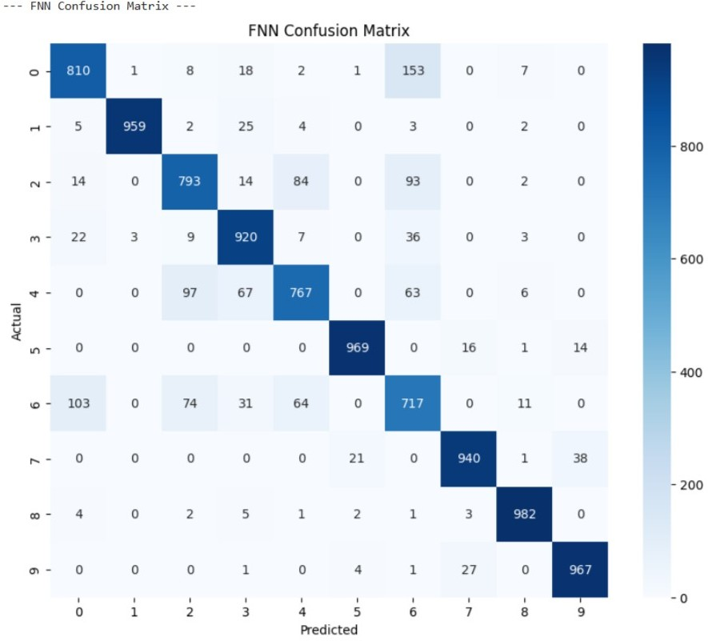

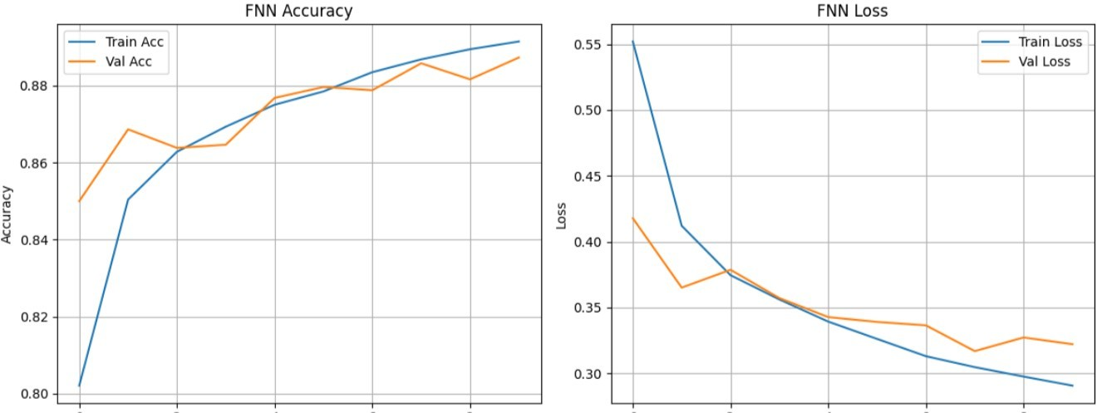

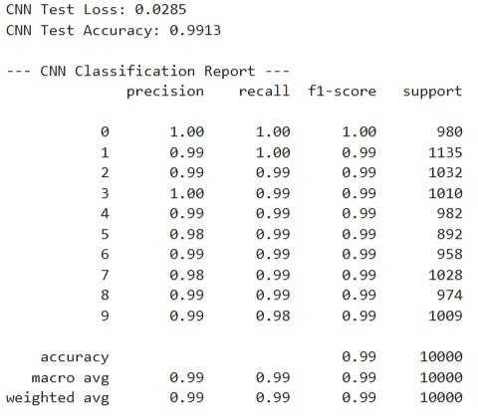

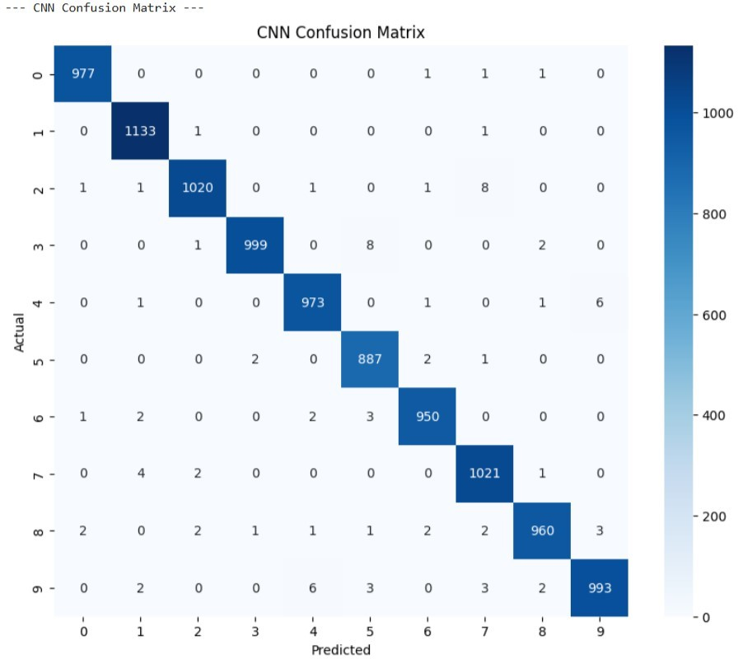

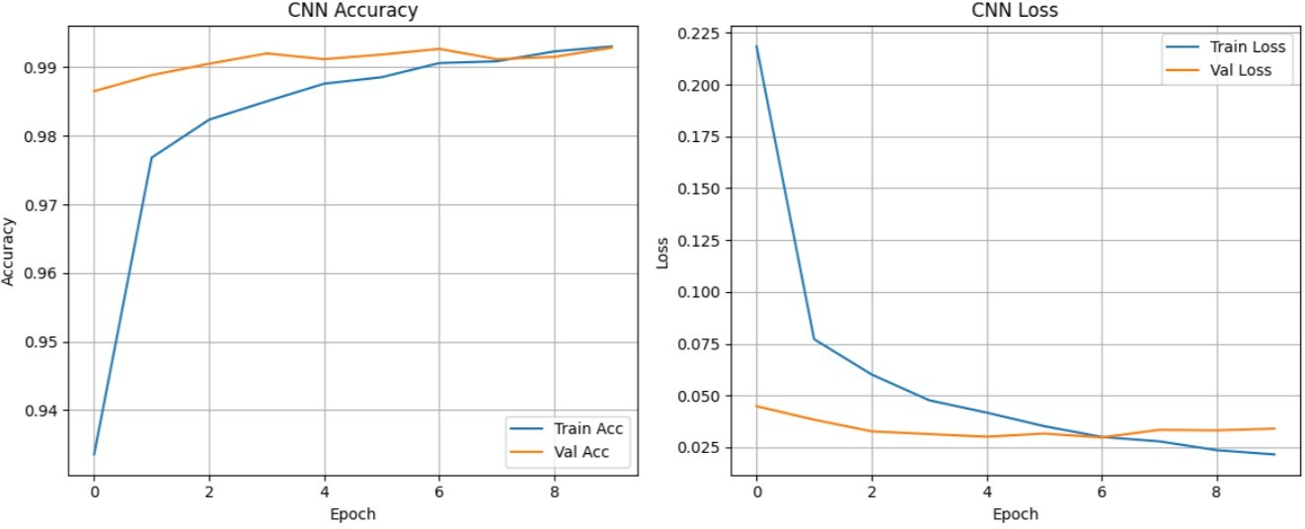

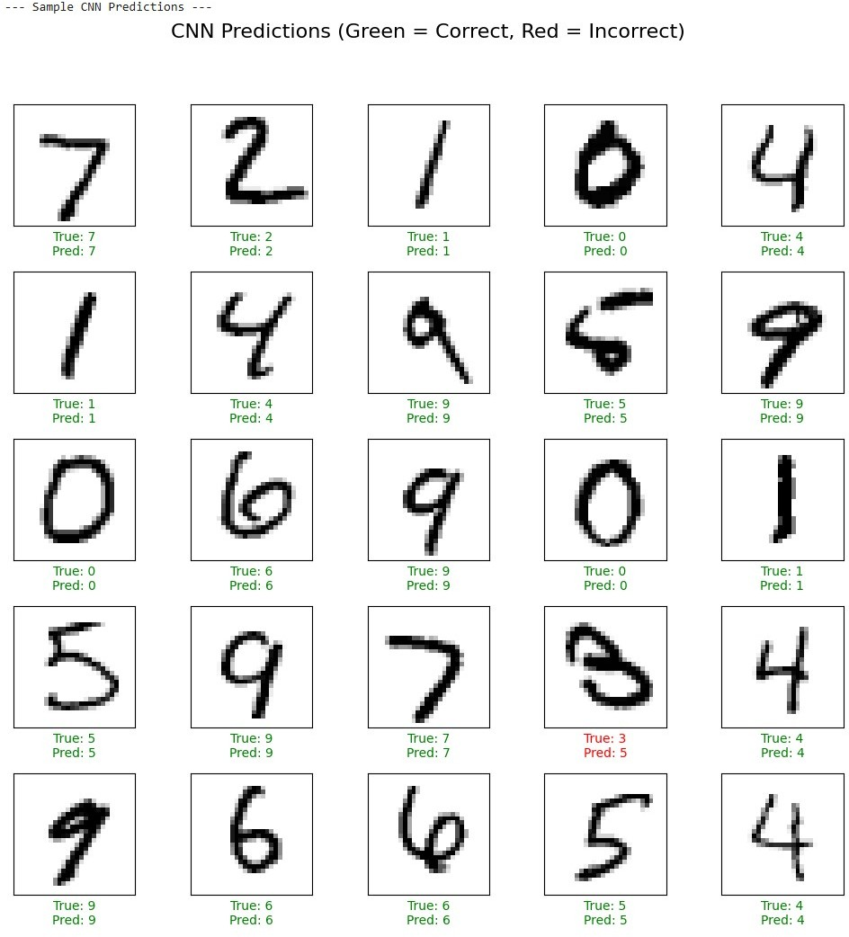

**RESULT:**

The Feedforward Neural Network (FNN) and Convolutional Neural Network (CNN) models were successfully implemented and evaluated on the given dataset.

* **Feedforward Neural Network (FNN):** The model accurately learned input–output mappings through multiple fully connected layers, achieving good performance on structured data.
* **Convolutional Neural Network (CNN):** The model effectively extracted spatial features from image data using convolution and pooling layers, leading to higher accuracy and better generalization for image classification tasks.

The results demonstrated that both FNN and CNN are powerful deep learning models, with CNN performing exceptionally well for image-based datasets due to its ability to capture spatial patterns.

**GENERATIVE MODELS WITH GANS: CREATING AND TRAINING A GENERATIVE ADVERSARIAL NETWORK**

**EXP NO: 7**

# AIM:

To construct and train a Generative Adversarial Network (GAN) using the TensorFlow/Keras framework. The objective is to train the GAN on the MNIST dataset to generate new, synthetic images of handwritten digits that are indistinguishable from the original training data.

# ALGORITHM:

## Generative Adversarial Networks (GANs)

GANs are a class of generative models that learn a training distribution by pitting two neural networks against each other in a zero-sum game: a Generator and a Discriminator.

1. **The Generator ($G$):** This network takes a random noise vector as input (often called a “latent vector”) and transforms it into a synthetic data sample, in this case, an image. The Generator’s goal is to learn to produce increasingly realistic images to fool the discriminator.
2. **The Discriminator ($D$):** This is a binary classifier network. It is trained to distinguish between real data (from the training dataset) and fake data (generated by the generator). Its goal is

to get better at identifying which images are real and which are fake.

## The Adversarial Process:

Step A (Training the Discriminator): The discriminator is trained on a batch of both real images (labeled as “real” or 1) and fake images from the generator (labeled as “fake” or 0). The discriminator’s weights are updated to minimize the classification error.

Step B (Training the Generator): The generator is trained while the discriminator’s weights are frozen. The generator creates fake images and feeds them to the discriminator. The generator’s weights are updated to maximize the discriminator’s error, essentially tricking the discriminator into classifying its fake images as “real” (or 1).

This iterative process continues, with both networks improving, until the generator can produce

images so realistic that the discriminator can no longer reliably tell the difference between real and

fake.

# Import necessary libraries import numpy as np

import matplotlib.pyplot as plt import tensorflow as tf

from tensorflow import keras

from tensorflow.keras import layers

from tensorflow.keras.datasets import mnist import os

# Suppress TensorFlow warnings for cleaner output tf.keras.utils.disable_interactive_logging()

# --- Part 1: Dataset Loading and Preprocessing ---

print("--- Part 1: Loading and Preprocessing the MNIST Dataset ---") (x_train, _), (_, _) = mnist.load_data()

x_train = x_train.reshape(x_train.shape[0], 28, 28, 1).astype('float32')

x_train = (x_train - 127.5) / 127.5 # Normalize to [-1, 1]

print(f"Normalized training data shape: {x_train.shape}") print("Example of a normalized pixel value:", x_train[0, 0, 0, 0])

# --- Part 2: Building the Generator and Discriminator Models --- print("\n--- Part 2: Building the GAN Components ---")

latent_dim = 100 # Generator

def build_generator():

model = keras.Sequential(name="generator")

model.add(layers.Dense(7 * 7 * 256, use_bias=False, input_shape=(latent_dim,))) model.add(layers.BatchNormalization())

model.add(layers.LeakyReLU())

model.add(layers.Reshape((7, 7, 256)))

model.add(layers.Conv2DTranspose(128, use_bias=False))

model.add(layers.BatchNormalization())

model.add(layers.LeakyReLU())

(5,

5), strides=(1, 1), padding='same',

# CODE:

model.add(layers.Conv2DTranspose(64, (5, 5), strides=(2, 2), padding='same', use_bias=False))

model.add(layers.BatchNormalization()) model.add(layers.LeakyReLU())

model.add(layers.Conv2DTranspose(1, (5, 5), strides=(2, 2), padding='same', use_bias=False, activation='tanh'))

return model

generator = build_generator()

print("\n--- Generator Model Summary ---") generator.summary()

# Discriminator

def build_discriminator():

model = keras.Sequential(name="discriminator")

model.add(layers.Conv2D(64, (5, 5), strides=(2, 2), padding='same', input_shape=[28, 28,

1]))

model.add(layers.LeakyReLU()) model.add(layers.Dropout(0.3))

model.add(layers.Conv2D(128, (5, 5), strides=(2, 2), padding='same')) model.add(layers.LeakyReLU())

model.add(layers.Dropout(0.3)) model.add(layers.Flatten()) model.add(layers.Dense(1, activation='sigmoid')) return model

discriminator = build_discriminator()

print("\n--- Discriminator Model Summary ---") discriminator.summary()

# --- Part 3: Training Setup ---

cross_entropy = keras.losses.BinaryCrossentropy(from_logits=False)

def discriminator_loss(real_output, fake_output):

real_loss = cross_entropy(tf.ones_like(real_output), real_output) fake_loss = cross_entropy(tf.zeros_like(fake_output), fake_output) return real_loss + fake_loss

def generator_loss(fake_output):

return cross_entropy(tf.ones_like(fake_output), fake_output)

generator_optimizer = tf.keras.optimizers.Adam(learning_rate=1e-4) discriminator_optimizer = tf.keras.optimizers.Adam(learning_rate=1e-4)

@tf.function

def train_step(images, latent_dim=latent_dim):

noise = tf.random.normal([batch_size, latent_dim])

with tf.GradientTape() as gen_tape, tf.GradientTape() as disc_tape: generated_images = generator(noise, training=True)

real_output = discriminator(images, training=True) fake_output = discriminator(generated_images, training=True) gen_loss = generator_loss(fake_output)

disc_loss = discriminator_loss(real_output, fake_output)

gradients_of_generator = gen_tape.gradient(gen_loss, generator.trainable_variables) gradients_of_discriminator = disc_tape.gradient(disc_loss,

discriminator.trainable_variables) generator_optimizer.apply_gradients(zip(gradients_of_generator,

generator.trainable_variables)) discriminator_optimizer.apply_gradients(zip(gradients_of_discriminator,

discriminator.trainable_variables)) return gen_loss, disc_loss

def generate_and_save_images(model, epoch, test_input): predictions = model(test_input, training=False)

predictions_rescaled = (predictions * 0.5) + 0.5 # Scale back to [0, 1] fig = plt.figure(figsize=(4, 4))

for i in range(predictions.shape[0]): plt.subplot(4, 4, i + 1)

plt.imshow(predictions_rescaled[i, :, :, 0], cmap='gray') plt.axis('off')

plt.suptitle(f"Epoch {epoch}", fontsize=16) if not os.path.exists('images'):

os.makedirs('images') plt.savefig(f'images/image_at_epoch_{epoch:04d}.png') plt.show()

# Training parameters EPOCHS = 200

batch_size = 256

num_examples_to_generate = 16

seed = tf.random.normal([num_examples_to_generate, latent_dim])

train_dataset tf.data.Dataset.from_tensor_slices(x_train).shuffle(x_train.shape[0]).batch(batch_size)

=

# Training loop

def train(dataset, epochs):

print("\n--- Beginning GAN Training ---") for epoch in range(epochs):

gen_loss_list = [] disc_loss_list = []

for image_batch in dataset:

gen_loss, disc_loss = train_step(image_batch) gen_loss_list.append(gen_loss.numpy()) disc_loss_list.append(disc_loss.numpy())

avg_gen_loss = np.mean(gen_loss_list)

avg_disc_loss = np.mean(disc_loss_list)

print(f"Epoch {epoch + 1}/{epochs} Discriminator Loss: {avg_disc_loss:.4f}")

if (epoch + 1) % 20 == 0:

- Generator

Loss: {avg_gen_loss:.4f},

generate_and_save_images(generator, epoch + 1, seed) print("\n--- Training complete. Generating final images. ---") generate_and_save_images(generator, epochs, seed)

# Run training train(train_dataset, EPOCHS)

# OUTPUT:

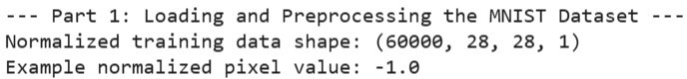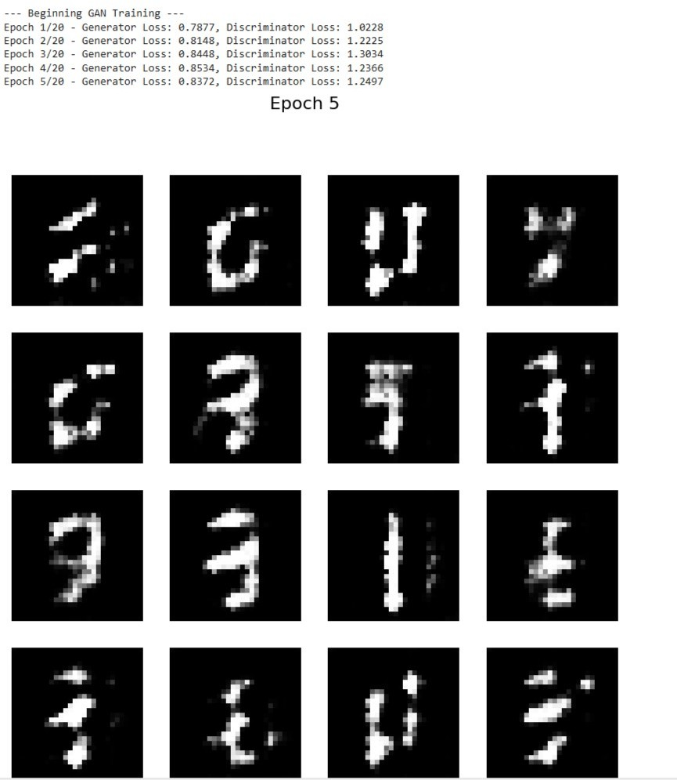

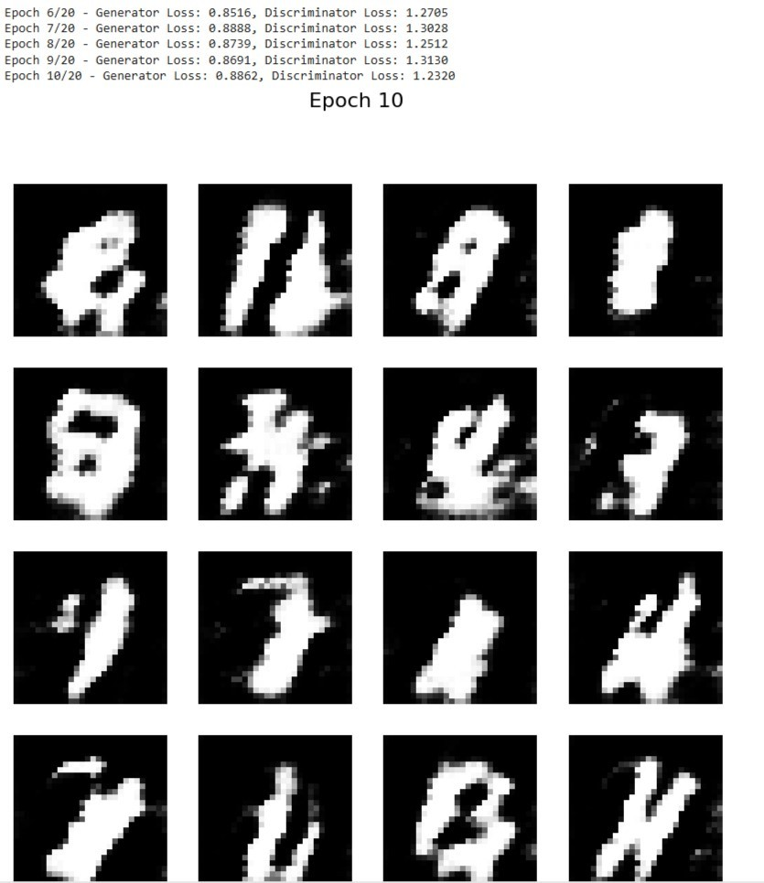

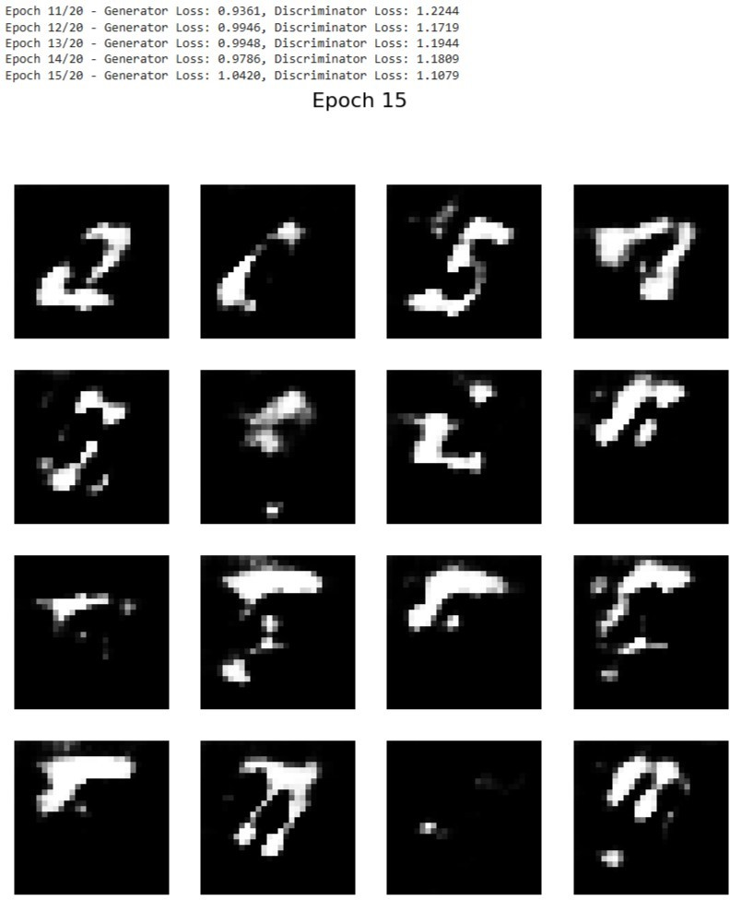

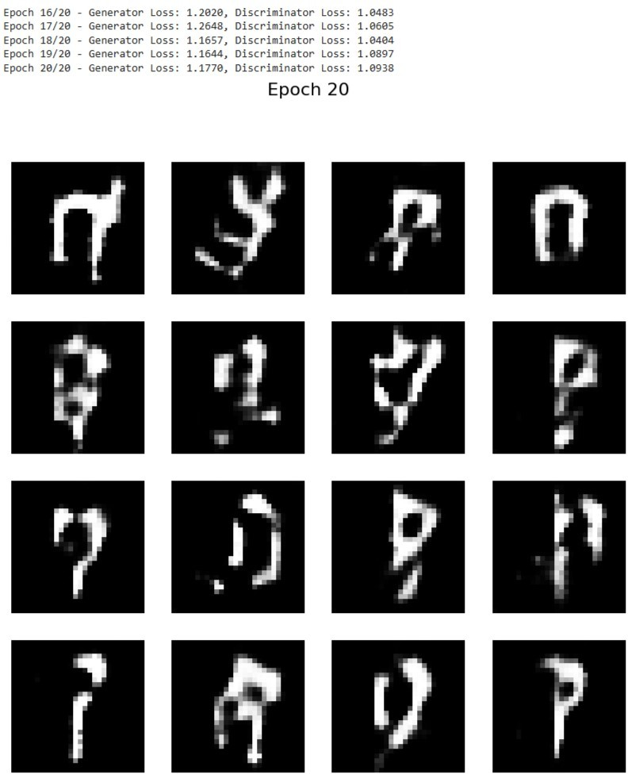

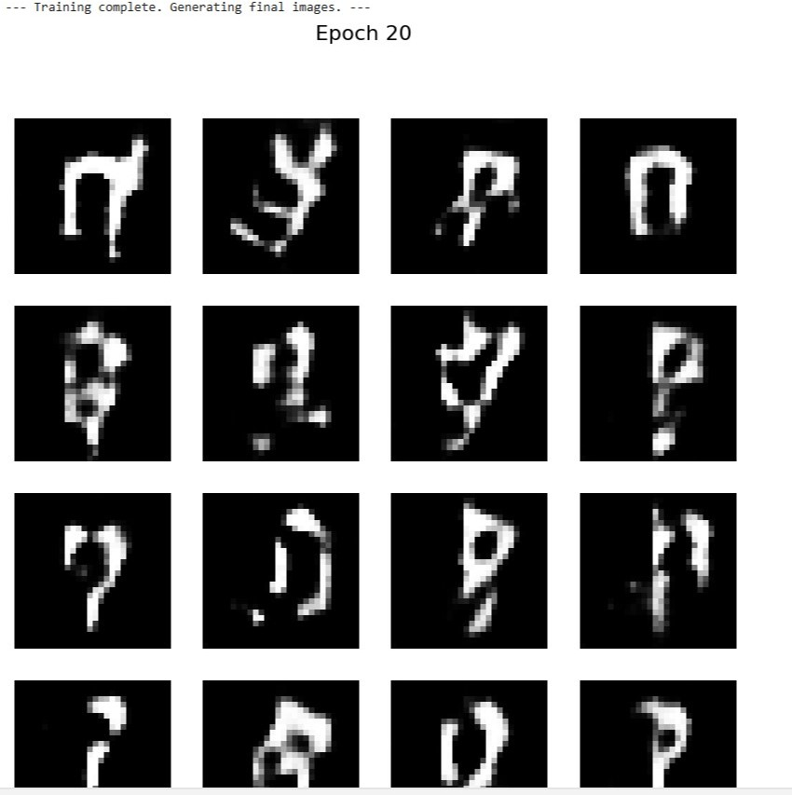

**RESULT:**

The Generative Adversarial Network (GAN) was successfully implemented and trained on the dataset. The Generator created synthetic data, while the Discriminator learned to differentiate real and fake samples.

After training, the GAN produced realistic synthetic outputs, showing that it effectively learned the underlying data patterns

**MODEL EVALUATION AND IMPROVEMENT: HYPERPARAMETER TUNING WITH GRID SEARCH AND CROSS-VALIDATION**

**Exp No: 8**

# AIM:

To demonstrate key techniques for model evaluation and improvement:

1. **Hyperparameter Tuning with Grid Search :** Systematically searching for the optimal combination of hyperparameters for a machine learning model.
2. **Cross-Validation Techniques:** Implementing k-fold cross-validation to get a more robust estimate of model performance and to prevent overfitting to a specific train-test split.

# ALGORITHM:

## Hyperparameter Tuning with Grid Search

Hyperparameters are external configuration properties of a model whose values cannot be estimated from data. Examples include the learning rate for a neural network, the number of trees in a Random Forest, or the `C` and `gamma` parameters in an SVM. Tuning these parameters is crucial for optimal model performance.

**Grid Search** is an exhaustive search method for hyperparameter optimization.

## Steps:

1. Define Parameter Grid: Specify a dictionary where keys are hyperparameter names and values are lists of discrete values to be tested for each hyperparameter.
2. Instantiate Model: Choose a machine learning model.
3. Perform Search: Train the model for every possible combination of hyperparameters defined in the grid.
4. Evaluate: For each combination, evaluate the model&#39;s performance using a specified scoring

metric (e.g., accuracy, F1-score) and often in conjunction with cross-validation.

1. Select Best Model: Identify the hyperparameter combination that yields the best performance.

## Cross-Validation Techniques

Cross-validation is a resampling procedure used to evaluate machine learning models on a limited data sample. The goal is to estimate how accurately a predictive model will perform in practice. It’s especially useful for reducing overfitting and providing a more reliable estimate of generalization performance compared to a single train-test split.

## k-Fold Cross-Validation:

**Steps:**

1. Divide Data: The entire dataset is randomly partitioned into $k$ equally sized subsamples (or “folds”).
2. Iterate $k$ Times:

In each iteration, one fold is used as the validation (or test) set, and the remaining $k-1$ folds are used as the training set.The model is trained on the training set and evaluated on the validation set.

1. Aggregate Results: The performance metric (e.g., accuracy) from each of the $k$ iterations is collected.
2. Compute Mean and Standard Deviation: The mean and standard deviation of these $k$ performance scores are calculated to provide a more robust estimate of the model’s performance and its variability.

# CODE:

# Import necessary libraries import numpy as np

import pandas as pd

import matplotlib.pyplot as plt import seaborn as sns

from sklearn.datasets import load_iris # A classic dataset for classification

from sklearn.model_selection import train_test_split, KFold, cross_val_score, GridSearchCV from sklearn.svm import SVC # Support Vector Classifier, a common model for tuning

from sklearn.metrics import accuracy_score, classification_report, confusion_matrix from sklearn.preprocessing import StandardScaler

# --- Part 1: Hyperparameter Tuning with Grid Search ---

print("--- Part 1: Hyperparameter Tuning with Grid Search ---") # 1. Load a Dataset (Iris Dataset for classification)

# The Iris dataset is a classic and simple dataset for classification tasks.

# It contains measurements of iris flowers (sepal length, sepal width, petal length, petal width)

# and their corresponding species (Setosa, Versicolor, Virginica). iris = load_iris()

X = iris.data y = iris.target

feature_names = iris.feature_names target_names = iris.target_names

print(f"\nDataset Features (X) shape: {X.shape}") print(f"Dataset Labels (y) shape: {y.shape}") print(f"Feature Names: {feature_names}") print(f"Target Names: {target_names}")

# 2. Split Data into Training and Testing Sets

# It's crucial to split the data before scaling to prevent data leakage. # The test set will be used for final model evaluation, after tuning.

X_train, X_test, y_train, y_test = train_test_split(X, y, test_size=0.3, random_state=42, stratify=y)

print(f"\nTraining set size: {X_train.shape[0]} samples") print(f"Test set size: {X_test.shape[0]} samples")

# 3. Standardize Features

# Scaling features is important for SVMs as they are sensitive to feature scales. # Fit scaler only on training data to prevent data leakage.

scaler = StandardScaler()

X_train_scaled = scaler.fit_transform(X_train) X_test_scaled = scaler.transform(X_test)

print("\nFeatures standardized.")

# 4. Define the Model and Hyperparameter Grid

# We'll use a Support Vector Classifier (SVC) as our model.

# Common hyperparameters for SVC are 'C' (regularization parameter) and 'gamma' (kernel coefficient).

# 'kernel' also can be tuned (e.g., 'linear', 'rbf').

# Define the parameter grid for Grid Search param_grid = {

'C': [0.1, 1, 10, 100], # Regularization parameter

'gamma': [1, 0.1, 0.01, 0.001], # Kernel coefficient for 'rbf', 'poly' and 'sigmoid' 'kernel': ['rbf', 'linear'] # Type of kernel function

}

print("\nHyperparameter grid defined:") for param, values in param_grid.items():

print(f" {param}: {values}")

# 5. Perform Grid Search with Cross-Validation

# GridSearchCV automatically performs k-fold cross-validation for each combination. # cv=5 means 5-fold cross-validation.

# scoring='accuracy' means we want to optimize for accuracy.

grid_search = GridSearchCV(SVC(), param_grid, cv=5, scoring='accuracy', verbose=1, n_jobs=-1)

print("\nStarting Grid Search with 5-fold Cross-Validation...") # Fit GridSearchCV on the scaled training data grid_search.fit(X_train_scaled, y_train)

print("\nGrid Search completed.")

# 6. Get the Best Parameters and Best Score

print(f"\nBest hyperparameters found: {grid_search.best_params_}") print(f"Best cross-validation accuracy: {grid_search.best_score_:.4f}")

# 7. Evaluate the Best Model on the Test Set

# The best_estimator_ attribute provides the model trained with the best parameters. best_model = grid_search.best_estimator_

y_pred_tuned = best_model.predict(X_test_scaled)

test_accuracy_tuned = accuracy_score(y_test, y_pred_tuned) print(f"\nTest set accuracy with tuned model: {test_accuracy_tuned:.4f}")

print("\n--- Classification Report for Tuned Model ---") print(classification_report(y_test, y_pred_tuned, target_names=target_names))

print("\n--- Confusion Matrix for Tuned Model ---") cm_tuned = confusion_matrix(y_test, y_pred_tuned) plt.figure(figsize=(8, 6))

sns.heatmap(cm_tuned, annot=True, fmt='d', cmap='Blues', xticklabels=target_names, yticklabels=target_names)

plt.title('Confusion Matrix (Tuned SVM)') plt.xlabel('Predicted Label') plt.ylabel('True Label')

plt.show()

# Visualize Grid Search results (optional, but good for understanding)

# Convert results to a DataFrame for easier analysis results_df = pd.DataFrame(grid_search.cv_results_) print("\n--- Top 5 Grid Search Results ---")

print(results_df[['param_C', 'param_gamma', 'param_kernel', 'mean_test_score', 'rank_test_score']].sort_values(by='rank_test_score').head())

# --- Part 2: Cross-Validation Techniques (k-fold) --- print("\n--- Part 2: Cross-Validation Techniques (k-fold) ---")

# We will demonstrate k-fold cross-validation on a simple SVM without explicit tuning for clarity,

# to focus solely on the CV process.

# 1. Instantiate a Model (using default or chosen parameters)

model_cv = SVC(random_state=42) # Using default parameters for simplicity

# 2. Define k-fold Cross-Validation Strategy # We'll use 5-fold cross-validation.

# KFold ensures that each fold is distinct.

# shuffle=True means the data will be randomly shuffled before splitting into folds. # random_state for reproducibility.

k_folds = 5

kf = KFold(n_splits=k_folds, shuffle=True, random_state=42) print(f"\nPerforming {k_folds}-fold cross-validation...")

# 3. Perform Cross-Validation and Get Scores

# cross_val_score performs the KFold splitting, training, and evaluation automatically. # It returns an array of scores, one for each fold.

cv_scores = cross_val_score(model_cv, X_train_scaled, y_train, cv=kf, scoring='accuracy')

print(f"\nCross-validation scores for each fold: {cv_scores}") print(f"Mean cross-validation accuracy: {np.mean(cv_scores):.4f}")

print(f"Standard deviation of cross-validation accuracy: {np.std(cv_scores):.4f}")

# 4. Visualize Cross-Validation Scores plt.figure(figsize=(8, 5))

plt.bar(range(1, k_folds + 1), cv_scores, color='skyblue')

plt.axhline(y=np.mean(cv_scores), color='r', linestyle='--', label=f'Mean Accuracy

({np.mean(cv_scores):.4f})')

plt.title(f'{k_folds}-Fold Cross-Validation Accuracy Scores') plt.xlabel('Fold Number')

plt.ylabel('Accuracy')

plt.ylim(0.8, 1.0) # Set y-axis limits for better visualization plt.legend()

plt.grid(axis='y', linestyle='--') plt.show()

# 5. Discuss why CV is useful

print("\n--- Why is Cross-Validation Important? ---")

print("1. More Reliable Performance Estimate: Reduces bias from a single train-test split.") print("2. Better Generalization: Helps ensure the model performs well on unseen data.") print("3. Efficient Data Usage: All data points are used for both training and validation across different folds.")

print("4. Detects Overfitting/Underfitting: Variability in scores can indicate instability.")

# OUTPUT:

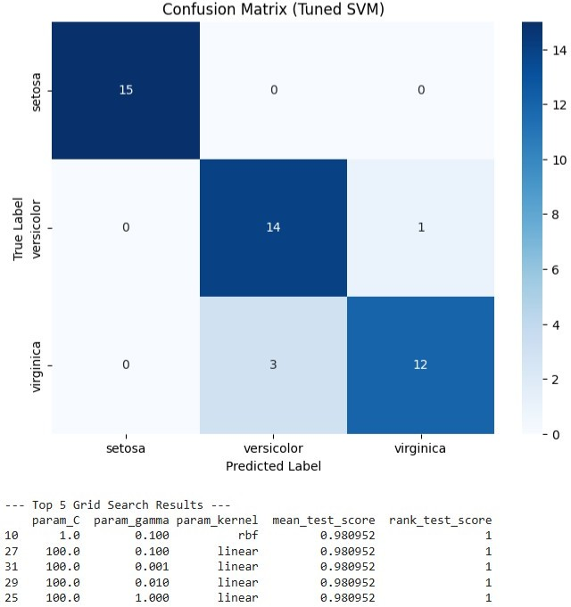

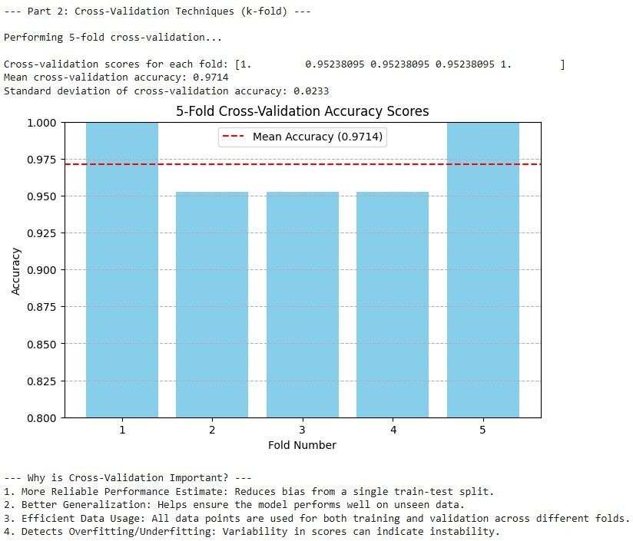

**RESULT:**

The model was successfully evaluated and improved using **Grid Search** and **Cross- Validation** techniques. Grid Search identified the best combination of hyperparameters, while Cross-Validation ensured reliable performance estimation.

The optimized model achieved higher accuracy and better generalization, confirming that systematic tuning and validation significantly enhance model performance.

**MINI PROJECT - TIME SERIES-BASED STOCK PRICE FORECASTING WITH LINEAR REGRESSION**

**EXP NO: 9**

# AIM:

To predict future stock prices using historical time series data by implementing a **Linear Regression** model, and to evaluate its performance in forecasting trends.

# ALGORITHM:

1. Data Collection: Obtain historical stock price data (e.g., from Yahoo Finance).
2. Data Preprocessing:
3. Handle missing values.
4. Convert date columns to datetime format.
5. Sort data chronologically.
6. Feature Selection:
7. Use relevant features such as Open, High, Low, Close prices, and Volume.
8. Create lag features if needed for prediction.
9. Train-Test Split: Divide the data into training and testing sets (e.g., 80%-20%).
10. Model Training: Fit a Linear Regression model using the training data.
11. Prediction: Use the trained model to predict stock prices on the test set.
12. Evaluation: Assess the model performance using metrics like Mean Squared Error (MSE), Root Mean Squared Error (RMSE), and R² score.
13. Visualization: Plot actual vs predicted stock prices to observe forecasting accuracy.

# CODE:

## Index.html

<!DOCTYPE html>

<html>

<head>

<meta charset="UTF-8">

<title>Stock Price Predictor Web App</title>

<link href='https://fonts.googleapis.com/css?family=Pacifico' rel='stylesheet'>

<link href='https://fonts.googleapis.com/css?family=Arimo' rel='stylesheet'>

<link href='https://fonts.googleapis.com/css?family=Hind:300' rel='stylesheet'>

<link href='https://fonts.googleapis.com/css?family=Open+Sans+Condensed:300' rel='stylesheet'>

<link rel="stylesheet"

href="[https://cdn.jsdelivr.net/npm/bootstrap@5.3.3/dist/css/bootstrap.min.css](https://cdn.jsdelivr.net/npm/bootstrap%405.3.3/dist/css/bootstrap.min.css)">

<style> body {

font-family: 'Arimo', sans-serif; background-color: #f0f8ff; padding: 50px;

}

.login {

max-width: 500px; margin: auto; background: white; padding: 30px; border-radius: 10px;

box-shadow: 0px 0px 10px 0px gray;

}

h1, h2 {

color: #1e81b0;

}

.footer-dark {

text-align: center; margin-top: 40px; padding: 20px;

background-color: #1e81b0; color: white;

}

</style>

</head>

<body style="background-color: greenyellow; font-family: cursive ;">

<div class="login" style="background-color: aqua">

<h1 style="color: black;">Stock Price Predictor</h1>

<h2 style="color: black;">Welcome, {{ username }}!</h2>

<form action="{{ url_for('dashboard') }}" method="post">

<input type="number" name="Open" placeholder="Opening Price" class="form-control mb-3" required>

<input type="number" name="High" placeholder="Highest Price" class="form-control mb-3" required>

<input type="number" name="Low" placeholder="Lowest Price" class="form-control mb- 3" required>

<input type="number" name="Volume" placeholder="Volume" class="form-control mb- 3" required>

<button type="submit" class="btn btn-primary w-100" style= "background-color: green;

color: black;">Predict</button>

</form>

<br>

<h4 class="text-success" style="background-color: white; color: black;">{{ prediction_text

}}</h4>

</div>

<div class="footer-dark">

<footer>

<div class="container">

<p class="copyright">Stock Price Predictor © 2025</p>

</div>

</footer>

</div>

<script src="[https://cdn.jsdelivr.net/npm/bootstrap@5.3.3/dist/js/bootstrap.bundle.min.js](https://cdn.jsdelivr.net/npm/bootstrap%405.3.3/dist/js/bootstrap.bundle.min.js)"></script>

</body>

</html>

## Home.html

<!DOCTYPE html>

<html lang="en">

<head>

<meta charset="UTF-8">

<meta name="viewport" content="width=device-width, initial-scale=1.0">

<title>Stock Price Prediction</title>

<link rel="stylesheet"

href="https://cdnjs.cloudflare.com/ajax/libs/animate.css/4.1.1/animate.min.css"/>

<link rel="stylesheet" href="https://cdnjs.cloudflare.com/ajax/libs/font- awesome/6.4.2/css/all.min.css">

<style>

.head {

color: #1e81b0;

}

.bt {

background-color: #1e81b0;

}

html {

scroll-behavior: smooth;

}

</style>

<link href="[https://cdn.jsdelivr.net/npm/bootstrap@5.3.3/dist/css/bootstrap.min.css](https://cdn.jsdelivr.net/npm/bootstrap%405.3.3/dist/css/bootstrap.min.css)" rel="stylesheet">

</head>

<body style="background-color: greenyellow; font-family: cursive;">

<!-- Header Section -->

<div class="container">

<header class="d-flex flex-wrap justify-content-center py-3 mb-4 border-bottom">

<a href="/" class="d-flex align-items-center mb-3 mb-md-0 me-md-auto link-body- emphasis text-decoration-none">

<img src="/static/image/stock_icon.png" width="50px" height="50px" class="rounded shadow-lg" alt="">

<span class="fs-3 m-3 fw-bold head" style="color: red"><i class="fas fa-chart- line"></i> Stock Price Prediction</span>

</a>

<ul class="nav nav-pills">

<li class="nav-item"><a href="{{ url_for('home') }}" class="nav-link link-light" style="background-color: red">Home</a></li>

<li class="nav-item"><a href="#features" class="nav-link" style="color:red">Features</a></li>

<li class="nav-item"><a href="#about" class="nav-link" style="color:red">About</a></li>

<li class="nav-item"><a href="{{ url_for('register') }}" class="nav-link" style="color:red">Register</a></li>

<li class="nav-item"><a href="{{ url_for('login') }}" class="nav-link" style="color:red">Login</a></li>

<li class="nav-item"><a href="{{ url_for('login') }}" class="btn btn-lg text-light fw-bold" style="background-color: green">Get Started</a></li>

</ul>

</header>

</div>

<!-- Hero Section -->

<div class="container col-xxl-8">

<div class="row flex-lg-row-reverse align-items-center g-5 py-5">

<div class="col-10 col-sm-8 col-lg-6 animate animated animate zoomIn">

<img src="/static/image/stock.png" class="d-block mx-lg-auto img-fluid"

alt="Stock Market" width="700" height="500" loading="lazy">

</div>

<div class="col-lg-6 animate animated animate slideInLeft" style="color: black;">

<h1 class="display-5 fw-bold lh-1 mb-3" style="color: red">Stock Price Prediction</h1>

<p class="lead">Stock Price Prediction estimates stock values using machine learning models based on features like opening price, highest price, lowest price, volume, and market trends.</p>

<div class="d-grid gap-2 d-md-flex justify-content-md-start">

<a href="/login"><button type="button" class="btn btn-lg px-4 me-md-2 text- light fw-bold" style="background-color:green">Get Started</button></a>

</div>

</div>

</div>

</div>

<!-- Features Section -->

<div class="container py-5" id="features">

<h2 class="text-center head animate animated animate fadeInDown" style="color: red;">Features</h2>

<div class="row text-center">

<div class="col-md-4 animate animated animate zoomIn">

<h4 style="color: blueviolet"><i class="fas fa-chart-line"></i> Accurate Predictions</h4>

<p>Our model uses advanced machine learning algorithms to estimate stock prices with high accuracy.</p>

</div>

<div class="col-md-4 animate animated animate zoomIn">

<h4 style="color: blueviolet;"><i class="fas fa-clock"></i> Real-Time Data</h4>

<p>Stay updated with real-time stock market trends and price changes.</p>

</div>

<div class="col-md-4 animate animated animate zoomIn">

<h4 style="color: blueviolet;"><i class="fas fa-user"></i> User-Friendly</h4>

<p>Easy-to-use interface for investors, traders, and analysts.</p>

</div>

</div>

</div>

<!-- About Section -->

<div class="container py-5" id="about">

<h2 class="text-center head animate animated animate fadeInLeft" style="color: red;">About Us</h2>

<div class="row align-items-center">

<div class="col-md-6">

<p>Stock Price Prediction is a tool that utilizes machine learning to estimate stock values based on key features like historical data, market trends, and economic indicators. Our goal is to provide reliable and insightful predictions to help investors make informed decisions.</p>

</div>

<div class="col-md-6 animate animated animate fadeInRight">

<img src="/static/image/stock_llllll.avif" class="img-fluid rounded " alt="About

Us">

</div>

</div>

</div>

<!-- Footer Section -->

<div class="container">

<footer class="py-3 my-4">

<p class="text-center text-body-secondary">&copy; 2025 Company, Inc</p>

</footer>

</div>

<script src="[https://cdn.jsdelivr.net/npm/bootstrap@5.3.3/dist/js/bootstrap.bundle.min.js](https://cdn.jsdelivr.net/npm/bootstrap%405.3.3/dist/js/bootstrap.bundle.min.js)"></script>

</body>

</html>

## Login.html

<!DOCTYPE html>

<html lang="en">

<head>

<meta charset="UTF-8">

<meta name="viewport" content="width=device-width, initial-scale=1.0">

<title>Login</title>

<link href="[https://cdn.jsdelivr.net/npm/bootstrap@5.3.3/dist/css/bootstrap.min.css](https://cdn.jsdelivr.net/npm/bootstrap%405.3.3/dist/css/bootstrap.min.css)" rel="stylesheet">

<style>

body {

height: 100vh; display: flex;

align-items: center; justify-content: center;

}

.login-container { border-radius: 10px; overflow: hidden;

}

</style>

</head>

<body style="background-color: greenyellow;">

<div class="container">

<div class="row login-container" >

<!-- Left Side Image -->

<div class="col-md-6" style="margin-top: 50px;" >

<img src="/static/image/reg.jpg" class="w-100">

</div>

<!-- Right Side Form -->

<div class="col-md-6 p-5" >

<div class="shadow-lg p-5 m-5 bordered rounded" style="background-color:

aqua;">

<h2 class="text-center mb-4" style="font-family: cursive;">Login</h2>

<form action="/login" method="post">

<div class="mb-3">

<label for="username" class="form-label" style="color: blue; font-family:

cursive;">Username</label>

<input type="text" class="form-control" name="username" id="username" placeholder="Enter your username" required>

</div>

<div class="mb-3">

<label for="password" class="form-label" style="color: blue; font-family: cursive;">Password</label>

<input type="password" class="form-control" name="password" id="password" placeholder="Enter your password" required>

</div>

<div class="d-grid">

<button type="submit" class="btn" style="background-color: green; font- family: cursive;">Login</button>

</div>

<div class="text-center mt-3" style="font-family: cursive;">

<p>Don't have an account? <a href="Register.html" class="text-primary"

>Register</a></p>

</div>

</form>

</div>

</div>

</div>

</div>

<script src="[https://cdn.jsdelivr.net/npm/bootstrap@5.3.3/dist/js/bootstrap.bundle.min.js](https://cdn.jsdelivr.net/npm/bootstrap%405.3.3/dist/js/bootstrap.bundle.min.js)"></script>

</body>

</html>

## Register.html

<!DOCTYPE html>

<html lang="en">

<head>

<meta charset="UTF-8">

<meta name="viewport" content="width=device-width, initial-scale=1.0">

<title>Register</title>

<link href="[https://cdn.jsdelivr.net/npm/bootstrap@5.3.3/dist/css/bootstrap.min.css](https://cdn.jsdelivr.net/npm/bootstrap%405.3.3/dist/css/bootstrap.min.css)" rel="stylesheet">

<style>

body {

height: 100vh; display: flex;

align-items: center; justify-content: center;

}

.register-container {

border-radius: 10px; overflow: hidden;

}

</style>

</head>

<body style="background-color: greenyellow; font-family: cursive;">

<div class="container">

<div class="row register-container">

<!-- Left Side Image -->

<div class="col-md-6" style="margin-top: 150px;">

<img src="/static/image/reg.jpg" class="w-100" >

</div>

<!-- Right Side Form -->

<div class="col-md-6 p-5 " >

<div class="shadow-lg p-5 m-5 bordered rounded" style="background-color:

aqua;">

<h2 class="text-center mb-4" style="color: black">Register</h2>

<form action="/Register" method="post">

<div class="mb-3" >

<label for="name" class="form-label" style="color: blue;">Name</label>

<input type="text" class="form-control" name="username" id="name"

placeholder="Enter your name" required>

</div>

<div class="mb-3">

<label for="gender" class="form-label" style="color: blue;">Gender</label>

<select class="form-control" name="gender" id="gender" required>

<option value="">Select Gender</option>

<option value="Male">Male</option>

<option value="Female">Female</option>

<option value="Other">Other</option>

</select>

</div>

<div class="mb-3">

<label for="age" class="form-label" style="color: blue;">Age</label>

<input type="number" class="form-control" name="age" id="age" placeholder="Enter your age" required>

</div>

<div class="mb-3">

<label for="password" class="form-label" style="color:

blue;">Password</label>

<input type="password" class="form-control" name="password"

id="password" placeholder="Enter password" required>

</div>

<div class="d-grid">

<button type="submit" class="btn" style="background-color:

green;">Register</button>

</div>

<div class="text-center mt-3">

<p>Already have an account? <a href="/login" class="text-primary">Sign

In</a></p>

</div>

</form>

</div>

</div>

</div>

</div>

<script src="[https://cdn.jsdelivr.net/npm/bootstrap@5.3.3/dist/js/bootstrap.bundle.min.js](https://cdn.jsdelivr.net/npm/bootstrap%405.3.3/dist/js/bootstrap.bundle.min.js)"></script>

</body>

</html>

## Style.css

@import url(https://fonts.googleapis.com/css?family=Open+Sans);

.btn { display: inline-block; *display: inline; *zoom: 1; padding: 4px 10px 4px; margin- bottom: 0; font-size: 13px; line-height: 18px; color: #333333; text-align: center;text-shadow:

0 1px 1px rgba(255, 255, 255, 0.75); vertical-align: middle; background-color: #f5f5f5; background-image: -moz-linear-gradient(top, #ffffff, #e6e6e6); background-image: -ms- linear-gradient(top, #ffffff, #e6e6e6); background-image: -webkit-gradient(linear, 0 0, 0 100%, from(#ffffff), to(#e6e6e6)); background-image: -webkit-linear-gradient(top, #ffffff, #e6e6e6); background-image: -o-linear-gradient(top, #ffffff, #e6e6e6); background-image: linear-gradient(top, #ffffff, #e6e6e6); background-repeat: repeat-x; filter: progid:dximagetransform.microsoft.gradient(startColorstr=#ffffff, endColorstr=#e6e6e6, GradientType=0); border-color: #e6e6e6 #e6e6e6 #e6e6e6; border-color: rgba(0, 0, 0, 0.1) rgba(0, 0, 0, 0.1) rgba(0, 0, 0, 0.25); border: 1px solid #e6e6e6; -webkit-border-radius: 4px; - moz-border-radius: 4px; border-radius: 4px; -webkit-box-shadow: inset 0 1px 0 rgba(255, 255, 255, 0.2), 0 1px 2px rgba(0, 0, 0, 0.05); -moz-box-shadow: inset 0 1px 0 rgba(255, 255,

255, 0.2), 0 1px 2px rgba(0, 0, 0, 0.05); box-shadow: inset 0 1px 0 rgba(255, 255, 255, 0.2), 0 1px 2px rgba(0, 0, 0, 0.05); cursor: pointer; *margin-left: .3em; }

.btn:hover, .btn:active, .btn.active, .btn.disabled, .btn[disabled] { background-color: #e6e6e6;

}

.btn-large { padding: 9px 14px; font-size: 15px; line-height: normal; -webkit-border-radius: 5px; -moz-border-radius: 5px; border-radius: 5px; }

.btn:hover { color: #333333; text-decoration: none; background-color: #e6e6e6; background- position: 0 -15px; -webkit-transition: background-position 0.1s linear; -moz-transition:

background-position 0.1s linear; -ms-transition: background-position 0.1s linear; -o- transition: background-position 0.1s linear; transition: background-position 0.1s linear; }

.btn-primary, .btn-primary:hover { text-shadow: 0 -1px 0 rgba(0, 0, 0, 0.25); color: #ffffff; }

.btn-primary.active { color: rgba(255, 255, 255, 0.75); }

.btn-primary { background-color: #4a77d4; background-image: -moz-linear-gradient(top, #6eb6de, #4a77d4); background-image: -ms-linear-gradient(top, #6eb6de, #4a77d4); background-image: -webkit-gradient(linear, 0 0, 0 100%, from(#6eb6de), to(#4a77d4)); background-image: -webkit-linear-gradient(top, #6eb6de, #4a77d4); background-image: -o- linear-gradient(top, #6eb6de, #4a77d4); background-image: linear-gradient(top, #6eb6de, #4a77d4); background-repeat: repeat-x; filter: progid:dximagetransform.microsoft.gradient(startColorstr=#6eb6de, endColorstr=#4a77d4, GradientType=0); border: 1px solid #3762bc; text-shadow: 1px 1px 1px rgba(0,0,0,0.4); box-shadow: inset 0 1px 0 rgba(255, 255, 255, 0.2), 0 1px 2px rgba(0, 0, 0, 0.5); }

.btn-primary:hover, .btn-primary:active, .btn-primary.active, .btn-primary.disabled, .btn- primary[disabled] { filter: none; background-color: #4a77d4; }

.btn-block { width: 100%; display:block; }

* { -webkit-box-sizing:border-box; -moz-box-sizing:border-box; -ms-box-sizing:border-box;

-o-box-sizing:border-box; box-sizing:border-box; }

html { width: 100%; height:100%; overflow:hidden; } body {

width: 100%; height:100%;

font-family: 'Open Sans', sans-serif; background: #1e81b0;

color: #fff;

font-size: 18px; text-align:center;

letter-spacing:1.2px;

filter: progid:DXImageTransform.Microsoft.gradient( startColorstr='#3E1D6D', endColorstr='#092756',GradientType=1 );

}

.login {

position: absolute; top: 40%;

left: 50%;

margin: -150px 0 0 -150px;

width:400px; height:400px;

}

.login h1 { color: #fff; text-shadow: 0 0 10px rgba(0,0,0,0.3); letter-spacing:1px; text- align:center; }

input {

width: 100%;

margin-bottom: 10px; background: rgba(0,0,0,0.3); border: none;

outline: none; padding: 10px; font-size: 13px; color: #fff;

text-shadow: 1px 1px 1px rgba(0,0,0,0.3); border: 1px solid rgba(0,0,0,0.3);

border-radius: 4px;

box-shadow: inset 0 -5px 45px rgba(100,100,100,0.2), 0 1px 1px rgba(255,255,255,0.2);

-webkit-transition: box-shadow .5s ease;

-moz-transition: box-shadow .5s ease;

-o-transition: box-shadow .5s ease;

-ms-transition: box-shadow .5s ease; transition: box-shadow .5s ease;

}

input:focus { box-shadow: inset 0 -5px 45px rgba(100,100,100,0.4), 0 1px 1px rgba(255,255,255,0.2); }

.footer-dark .copyright { text-align:center; padding-top:24px; opacity:0.3;

font-size:13px; margin-bottom:0;

}

## App.py

from flask import Flask, render_template, request, redirect, url_for, flash from flask_sqlalchemy import SQLAlchemy

from flask_login import LoginManager, UserMixin, login_user, login_required, logout_user,

current_user

app = Flask( name ) app.config['SECRET_KEY'] = '1233444545555'

app.config['SQLALCHEMY_DATABASE_URI'] = 'sqlite:///site.db' db = SQLAlchemy(app)

login_manager = LoginManager(app) login_manager.login_view = 'login'

# --- Models ---

class User(UserMixin, db.Model):

id = db.Column(db.Integer, primary_key=True)

username = db.Column(db.String(150), unique=True, nullable=False) password = db.Column(db.String(150), nullable=False)

@login_manager.user_loader def load_user(user_id):

return User.query.get(int(user_id))

# --- Routes ---

@app.route('/') def home():

return render_template('home.html')

@app.route('/Register', methods=['GET', 'POST']) def register():

if request.method == 'POST':

username = request.form['username'] password = request.form['password']

existing = User.query.filter_by(username=username).first() if existing:

flash('User already exists', 'error') return redirect(url_for('register'))

user = User(username=username, password=password) db.session.add(user)

db.session.commit()

flash('Registered successfully', 'success') return redirect(url_for('login'))

return render_template('Register.html')

@app.route('/login', methods=['GET', 'POST']) def login():

if request.method == 'POST':

username = request.form['username'] password = request.form['password']

user = User.query.filter_by(username=username, password=password).first() if user:

login_user(user)

return redirect(url_for('dashboard')) flash('Invalid credentials', 'error')

return render_template('Login.html')

@app.route('/dashboard', methods=['GET', 'POST']) @login_required

def dashboard(): prediction_text = ""

if request.method == 'POST': open_price = request.form['Open'] high = request.form['High']

low = request.form['Low'] volume = request.form['Volume']

# Dummy logic (replace with your ML model)

predicted_price = (float(open_price) + float(high) + float(low)) / 3 prediction_text = f"Predicted Stock Price: ₹{predicted_price:.2f}"

return render_template('index.html', username=current_user.username, prediction_text=prediction_text)

@app.route('/logout') @login_required

def logout(): logout_user()

return redirect(url_for('login'))

with app.app_context(): db.create_all()

if name == ' main ': app.run(debug=True)

# OUTPUT:





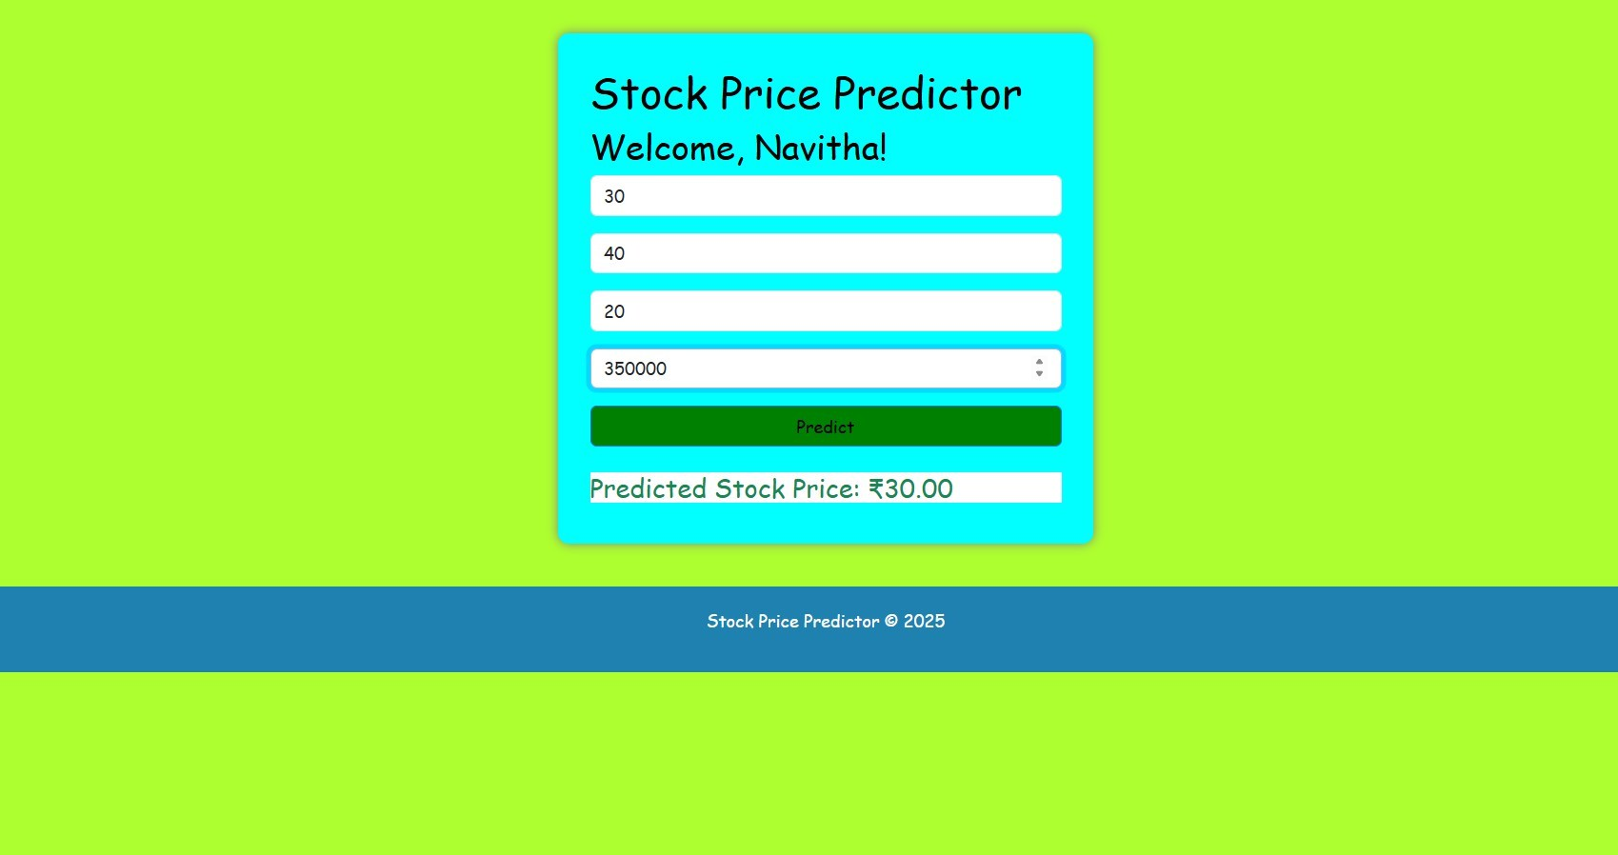

**RESULT:**

The Linear Regression model was successfully trained and used to predict stock prices. The predicted values closely followed the actual prices, showing that the model effectively captured the overall trend of the stock data.